Section 5-1 Angles of Triangles
Content Objective: Students will prove and apply the Triangle Angle-Sum Theorem, Exterior Angle Theorem, and Triangle Angle-Sum Theorem Corollaries.

Vocabulary: interior angle of a triangle, triangle angle sum theorem, isosceles triangle, scalene triangle, right triangle, acute triangle, obtuse triangle, exterior angle of a triangle, remote interior angles, exterior angle theorem, corollary,

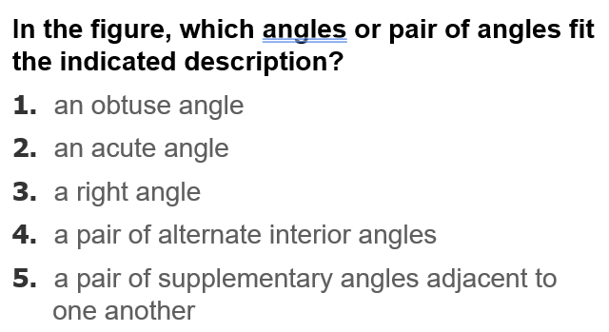  Warm up exercise | 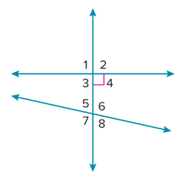

Example #1   | 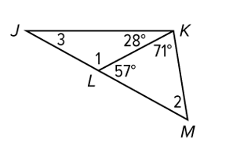

LEARN…  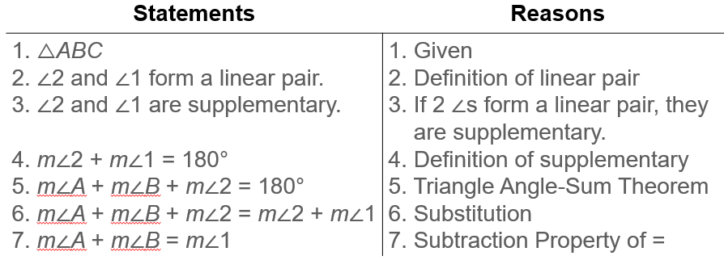  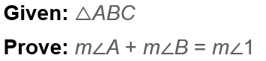 | 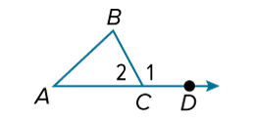

Example #2   | 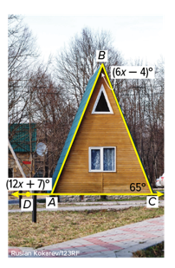
More Practice…   | 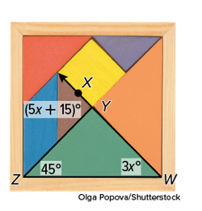

Example: 3  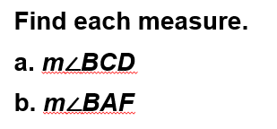 | 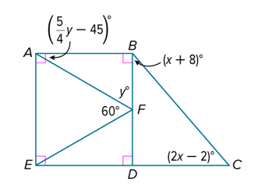

Exit Ticket  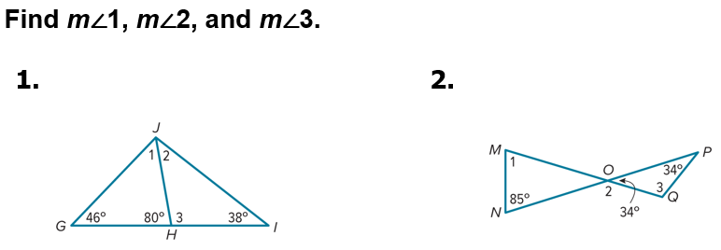 | 