Section 1-1 Points, Lines, and Planes
Content Objective:
Students will analyze figures to identify points, lines, and planes and identify intersections of lines and planes.

Vocabulary: Euclidean Geometry, coordinate geometry, undefined terms, defined terms, definition, postulate or axiom, theorem, point, line, plane, space, collinear, noncollinear, coplanar, noncoplanar, intersection.
Warm up exercise
Subtract.
1. 3 − 7
2. 8 − (−2)
3. 15 − (−18)
4. 37 − 48
5. WEATHER At 7 P.M., the temperature was 4°C. By 8 P.M., it had increased 2°C. By 9 P.M., it had decreased 1°C. By 10 P.M., it had decreased 15°C. What was the temperature at 10 P.M.?

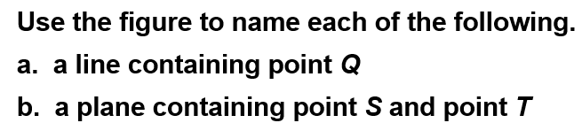  Example #1 | 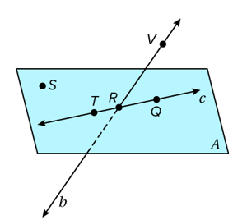

Example #2  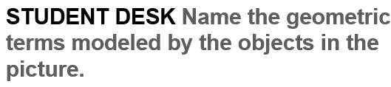 | 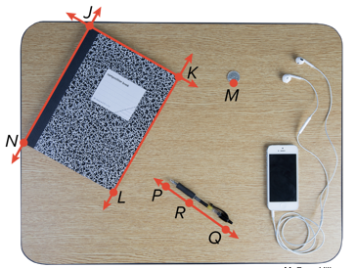

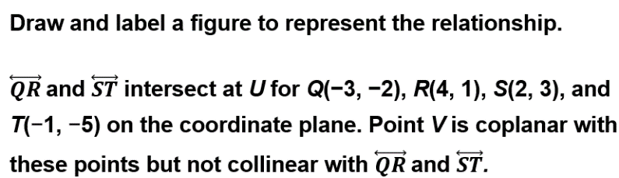  Example #3 | 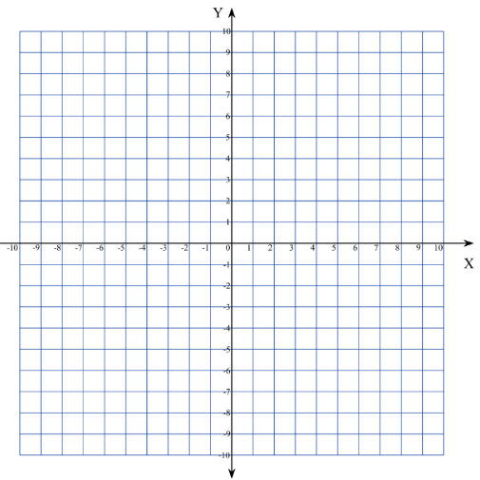

Example #4  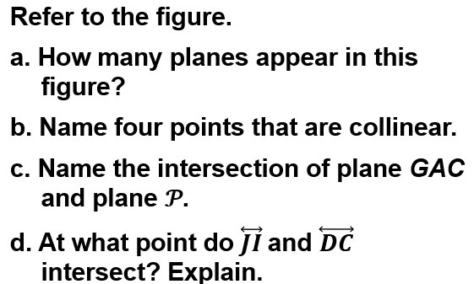 | 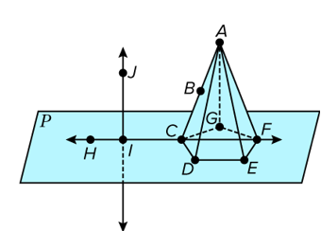

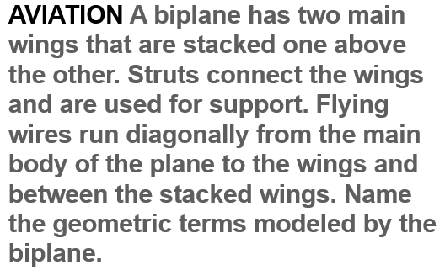  Example #5 | 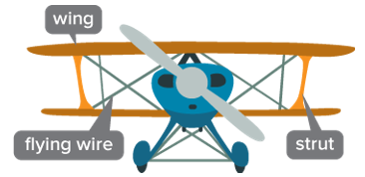

Exit Ticket  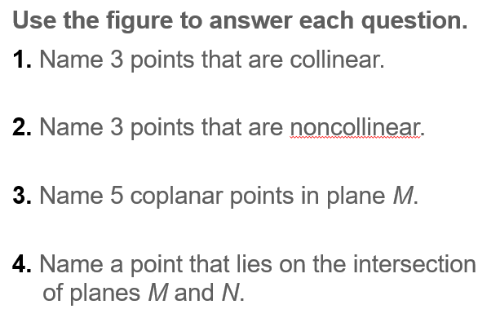 | 