Section 1-2 Line Segments
Content Objective:
Students will calculate measures of line segments.

Vocabulary: line segment, betweenness of points (line segment postulate), congruent, congruent segments, constructions
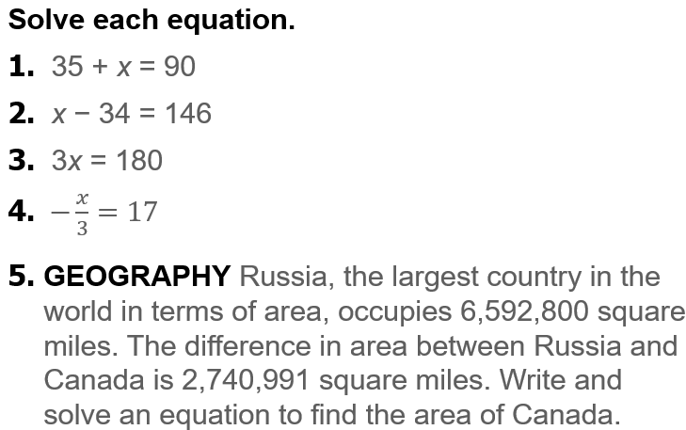  Warm up exercise | 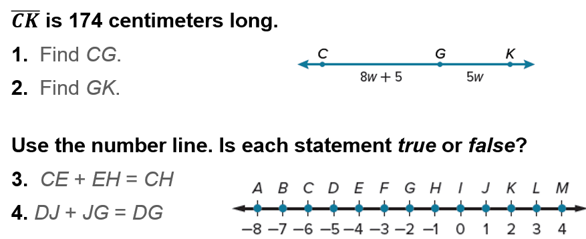  Warm up exercise

Example #1  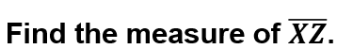 | 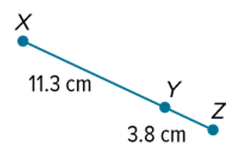

Example #2  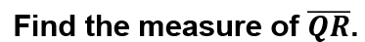 | 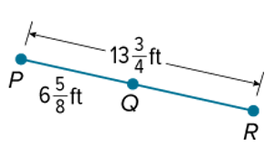

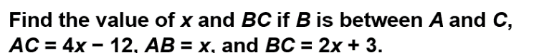
Example #3

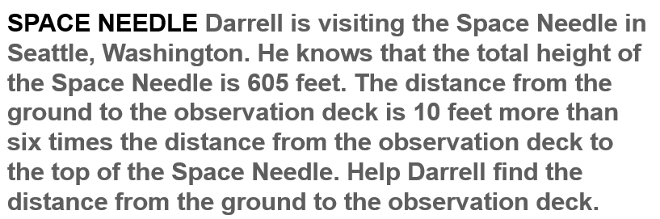
Example #4

Construction   | 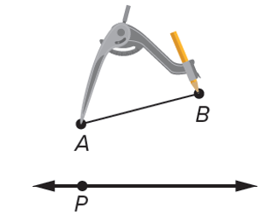

Exit Ticket   | 