Section 3-4 Writing Proofs
Content Objective: Students analyze and construct viable arguments.

Vocabulary: proof, two column proof, deductive argument, flow proof, paragraph proof

Example #1  ARCHITECTURE Explain how the photo illustrates that each statement is true. Then state the postulate that can be used to show that the statement is true.  a. Lines 𝓃 and 𝓅 intersect at point D.  b. Points A, B, and D determine a plane.  c. The plane that contains A, D, and E intersects the plane that contains F, G, and E in line 𝓀. | 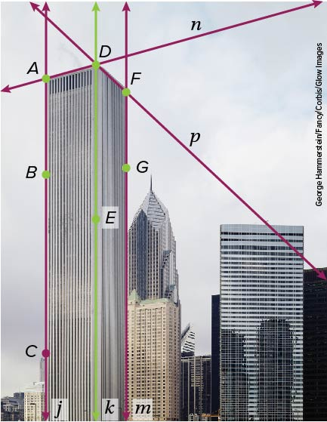

Example #2
Determine whether each statement is sometimes, always, or never true. Justify your argument.
a. The intersection of three planes is a line.
b. Line 𝓇 contains only point P.
c. Through points H and K, there is exactly one line.

Example #3  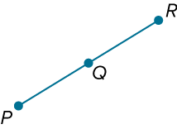  Complete the two-column proof.  Given: Q is the midpoint of $\overline{PR}$.  Prove: $\overline{PQ}$ ≅ $\overline{QR}$ | 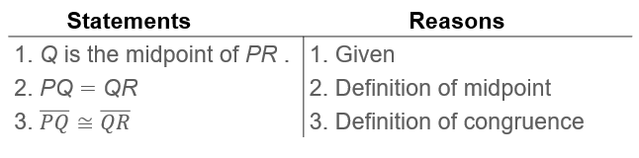

Example #4  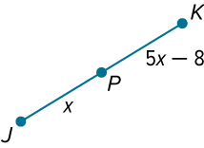  Write a flow proof to prove that x = 2.  Given: P is the midpoint of $\overline{JK}$.  Prove: x = 2 | 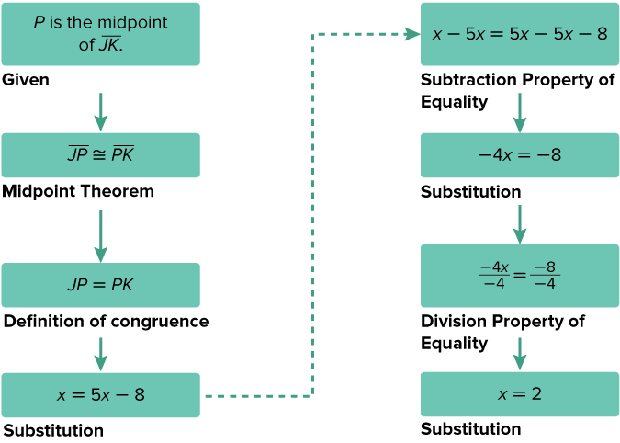

Example #5  Given that C is between A and B and $\overline{AC}$ ≅ $\overline{CB}$, write a paragraph proof to show that C is the midpoint of $\overline{AB}$. | If C is between points A and B, then by the definition of betweenness, A, B, and C are collinear and AC + CB = AB. If $\overline{AC}$ ≅ $\overline{CB}$, then by the definition of congruence, the segments have the same measure, which means that AC = CB. From the definition of midpoint of a segment, if C is between points A and B and AC = CB, then C is the midpoint of $\overline{AB}$.

Example #6

Example #7

