Section 3-6 Proving Angle Relationships
Content Objective: Students prove theorems about angles.

Vocabulary: Reflexive property, Symmetry Property, Transitive Property

Example #1  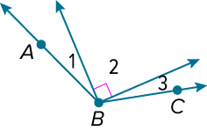  What is m∠3 if m∠1 = 23° and m∠ABC = 131°? | 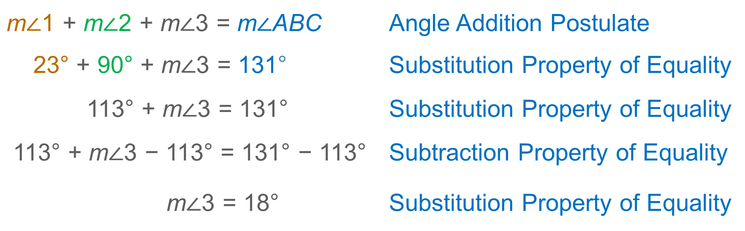

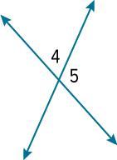
Example #2
Check
What is m∠4 if m∠5 = 2x° and
m∠4 = (x + 9)°?

Example #3  SHELVING Mae Lin is installing shelves in her room. One of the brackets she chose for her shelves is shown. If m∠3 = 55°, what is m∠4?  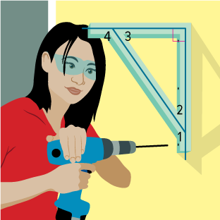 | 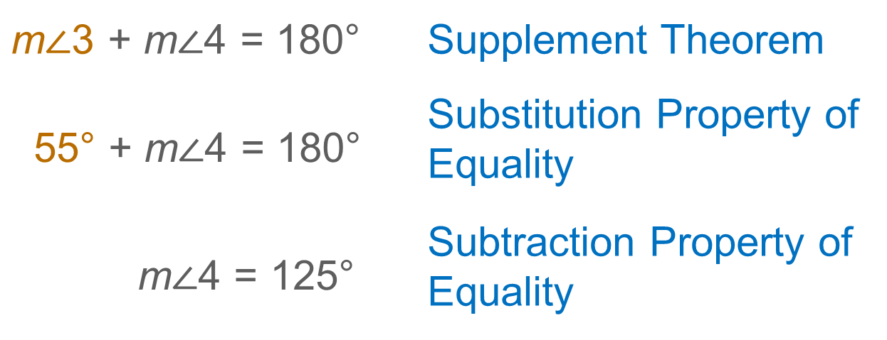

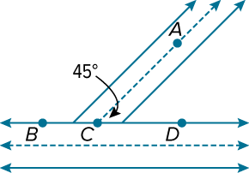  Example #4  Check  CITY PLANNING A city planner is designing an entrance ramp for a freeway. In the diagram, m∠ACD = 45°. What is m∠BCA? Show your calculations and justify each step. | 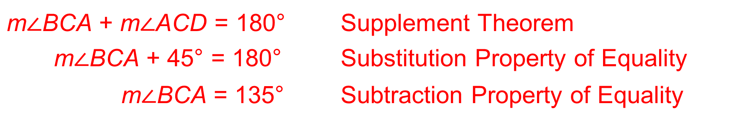

Example #5  In the figure, ∠ABE and ∠DBC are right angles. Write a proof.  Given: ∠ABE and ∠DBC are right angles.  Prove: ∠ABD ≅ ∠EBC  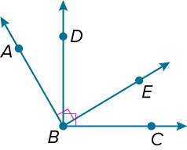 | 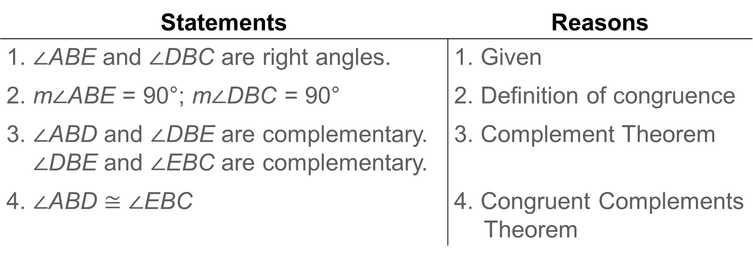

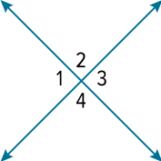  Example #6  Write a proof.  Given: ∠1 ≅ ∠2  Prove: ∠3 ≅ ∠4 | 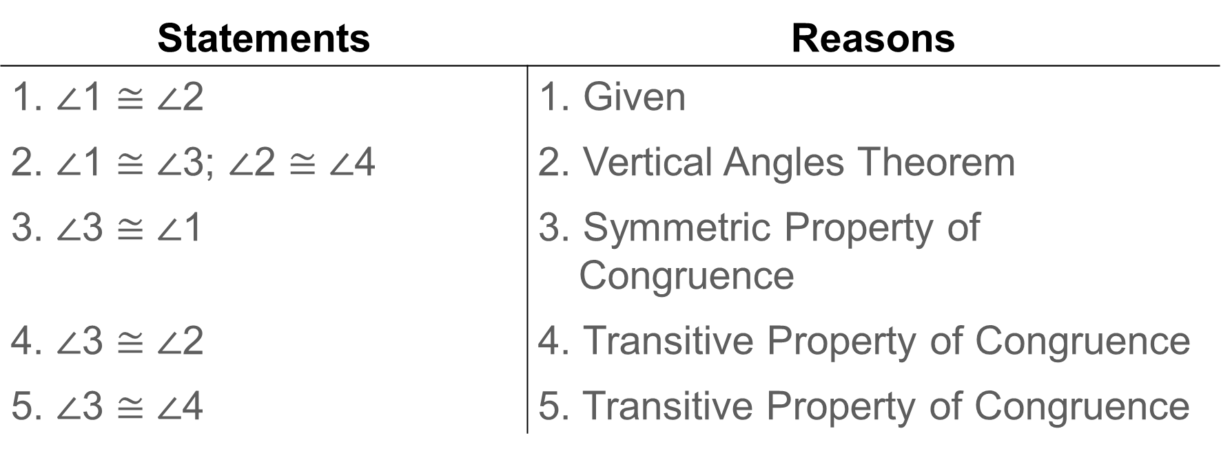

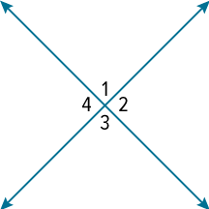  Example #7  Write a proof.  Given: ∠1 ≅ ∠4  Prove: ∠1 and ∠2 are right angles. | 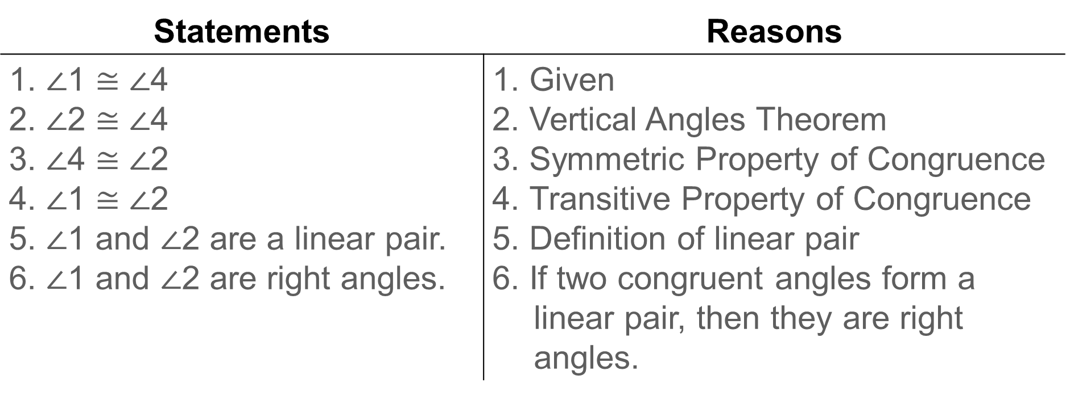

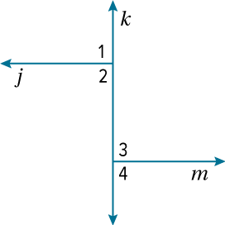  Example #8  Check  Complete the proof.  Given: Lines 𝒿 and 𝓀 are perpendicular.  ∠1 ≅ ∠4  Prove: ∠2 ≅ ∠4 | 