Section 6-7 Inequalities of Two Triangles
Content Objective: Students solve problems using the Hinge Theorem and its converse.
Vocabulary: Hinge Theorem, converse of Hinge Theorem

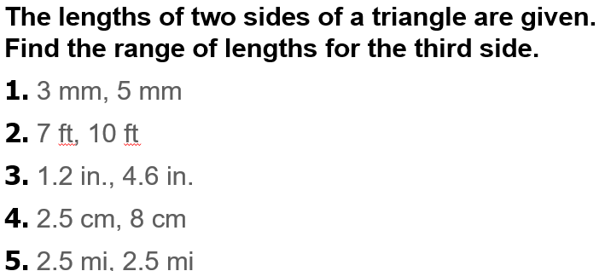
Warm up exercise

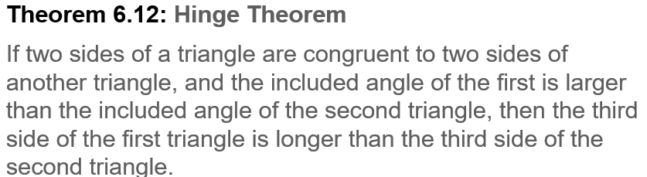
Notes…
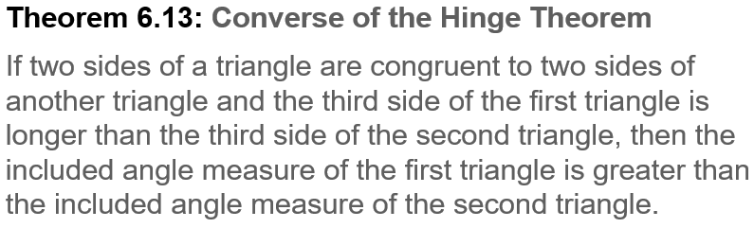

Example #1  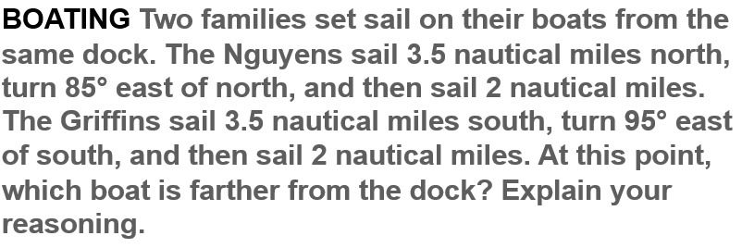 | 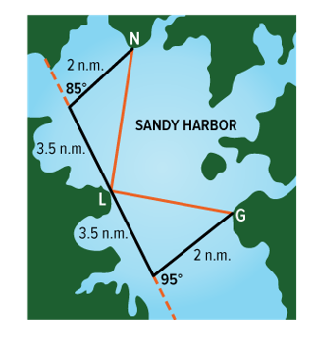

Example #2  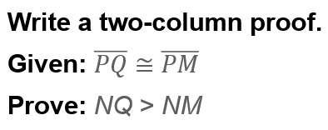 | 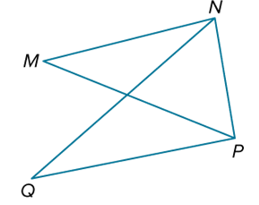

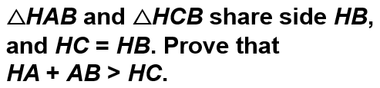  Example #3 | 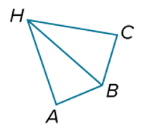

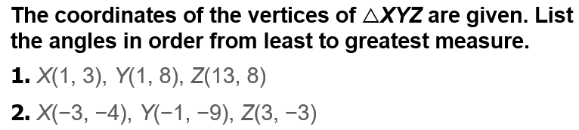  Exit Ticket… | 