Section 7-4 Rectangles
Content Objective: Students use the properties of rectangles to determine whether a parallelogram is a rectangle and to write proofs.

Vocabulary: rectangles, properties of rectangles, diagonals of a rectangle

Warm up exercise  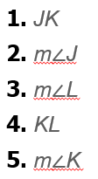 | 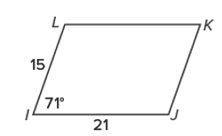

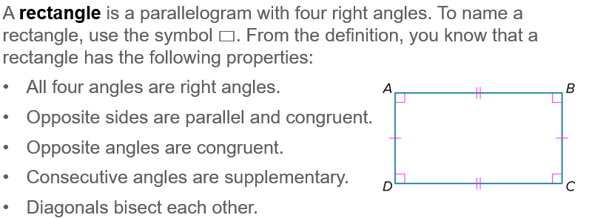
Notes…

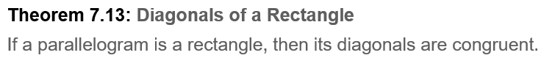

Example #1  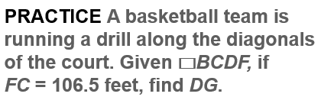 | 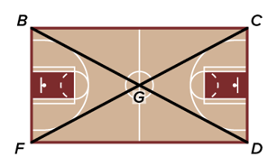

Example #2  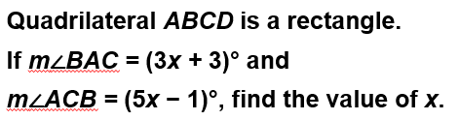 | 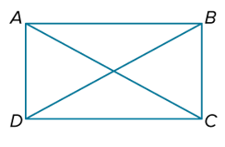

Example #3  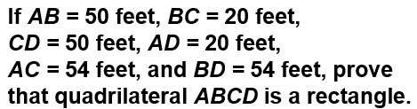 | 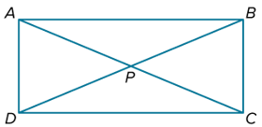

Example #4  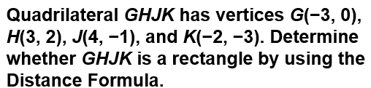 | 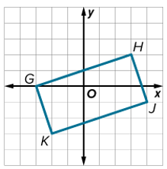

Exit Ticket  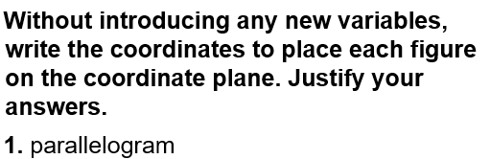 | 