Section 3-7 Parallel Lines and Transversals
Content Objective: Students identify and use relationships between parallel lines and transversals.

Vocabulary: Skew lines, transversals, parallel lines, perpendicular lines

Example #1
Identify each of the following using the cube shown. Assume lines and planes that appear to be parallel or perpendicular are parallel or perpendicular, respectively.
a. all lines skew to $\overset{⃡}{BC}$
b. all lines parallel to $\overset{⃡}{EH}$
c. all planes parallel to plane DCH

Example #2
Classify the relationship between each pair of angles as alternate interior, alternate exterior, corresponding, or consecutive interior angles.
∠4 and ∠5
∠3 and ∠7
∠3 and ∠5
∠1 and ∠8

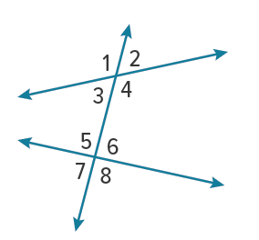

Example #3
Identify the transversal connecting each pair of angles in the photo. Then classify the relationship between each pair of angles.
∠1 and ∠8
∠3 and ∠6
∠6 and ∠7
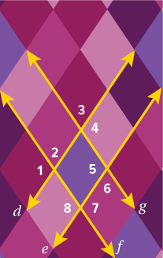

Example #4
RAILROADS Crossties 𝒾 and 𝓀 are parallel. Both crossties are intersected by crosstie 𝒽. If m∠1 = 42°, find m∠7.

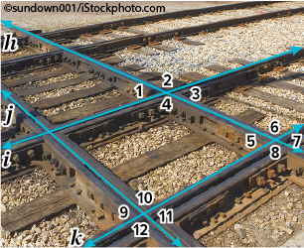

Example #5
Use the figure to find the value of the indicated variable. Justify your reasoning.
a. If m∠3 = (4x + 7)° and m∠6 = (5x − 13)°, find the value of x.
b. Find the value of y if m∠8 = 68° and m∠3 = (3y − 2)°.

