Section 3-8 Slopes and Equations of Lines
Content Objective: Students classify lines as parallel, perpendicular, or neither by using the slope criteria.

Vocabulary: slopes, slope intercept form, parallel lines, perpendicular lines

Example #1
Determine whether $\overset{⃡}{AB}$ and $\overset{⃡}{CD}$ are parallel, perpendicular, or neither for A(3, 6), B(−9, 2), C(5, 4), and D(2, 3). Graph each line to verify your answer.

Example #2  Determine whether each pair of lines is parallel, perpendicular, or neither.  a. $\overset{⃡}{RS}$ and $\overset{⃡}{TU}$  b. $\overset{⃡}{EF}$ and $\overset{⃡}{DG}$ | 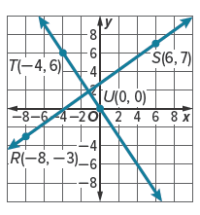

Example #3
Determine whether each pair of lines is parallel, perpendicular, or neither.
a. y = 3x − 2; $y-0=-\frac{1}{3}\left(x-2\right)$
b. y = 3; x = 1
c. $y-5=-\frac{3}{4}\left(x+2\right)$; $y=-\frac{3}{4}x+2$
d. y = 2x + 3; $y-1=\frac{1}{2}\left(x+2\right)$
e. x = −2; x = 4

Example #4  DESIGN Valentina is designing a park using grid paper. She wants to build a sidewalk that connects with the fountain at P(0, 1) and is perpendicular to the existing sidewalk that passes through points Q(−6, −2) and R(0, −6). Graph the line that represents the new sidewalk. | 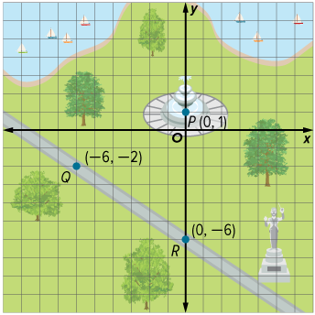

Example #5
Write an equation in slope-intercept form for the line parallel to $y=-\frac{3}{4}x+3$ containing (−3, 6).

