Section 7-6 Trapezoids and Kites
Content Objective: Students recognize and apply the properties of trapezoids and kites.
Vocabulary: Isosceles trapezoids, Kites, Properties of Isosceles Trapezoids and Kites.

Warm up exercise
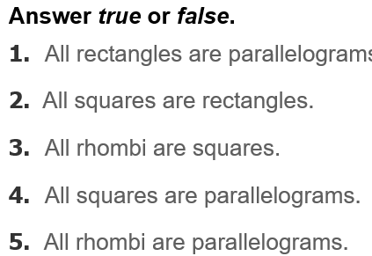

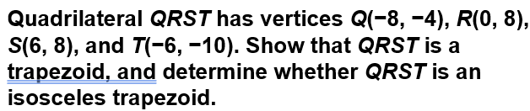  Example #2 | 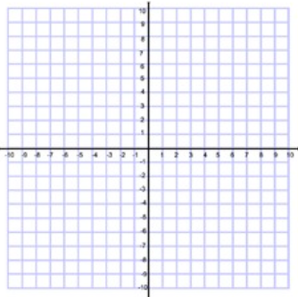

Example #3  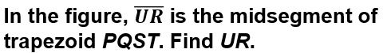 | 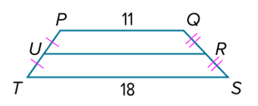

Example #4  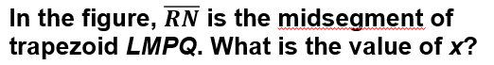 | 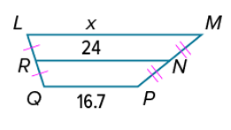

Example #5  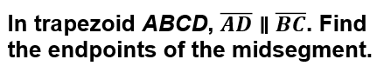 | 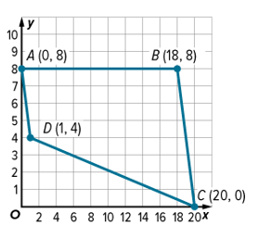

Example #6   | 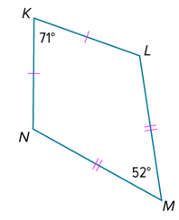

Example #7  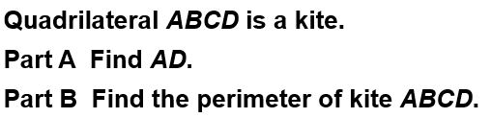 | 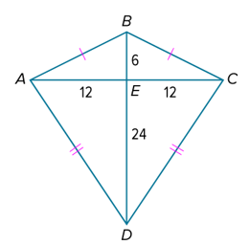

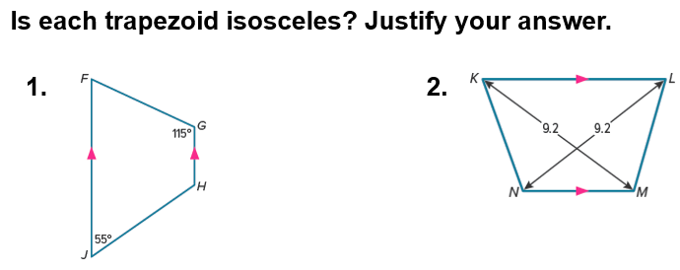  Exit Ticket | 