Section 9-1 Pythagorean Theorem and It’s Converse
Content Objective: Students will solve problems using the Pythagorean Theorem and its converse.

Vocabulary: Pythagorean Theorem, Pythagorean triple, Converse of Pythagorean theorem

Warm up exercise
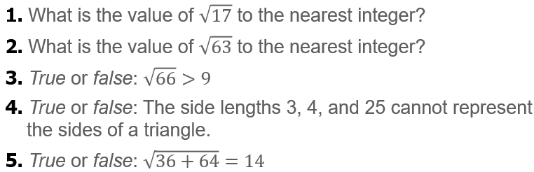

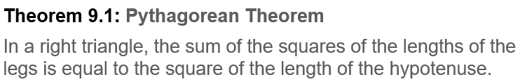
Notes…

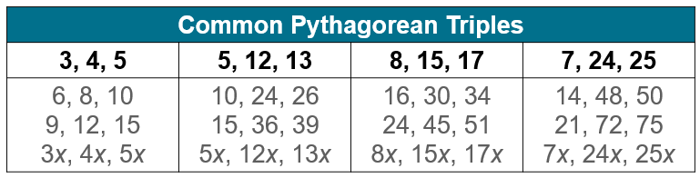

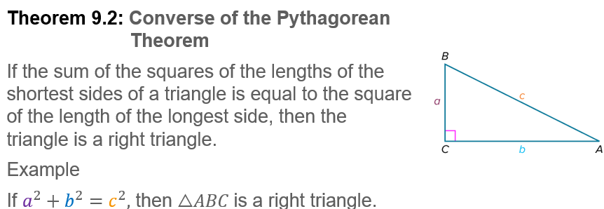

Example #1   | 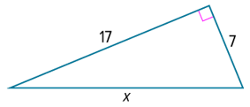

Example #2   | 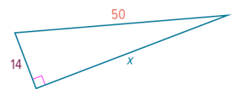


Example #3

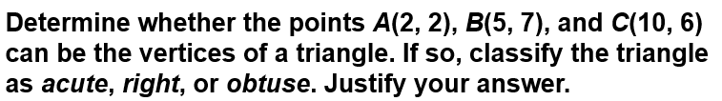  Example #4 | 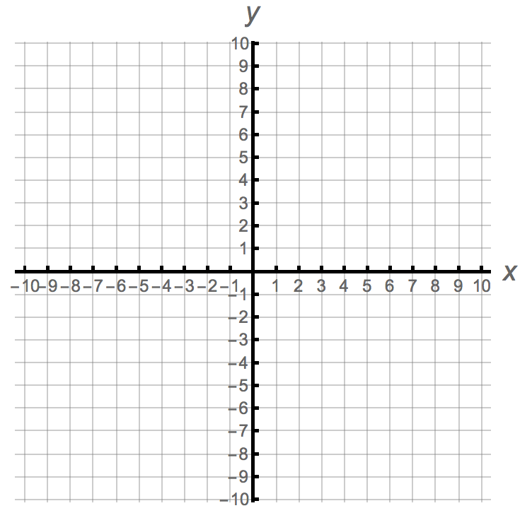

Exit Ticket
