Section 4-3 Rotation
Content Objective: Students will use rigid transformations to rotate figures on the coordinate plane and describe the effects of the rotations.

Vocabulary: Counterclockwise, Clockwise, rotation from the origin, rotation from a point

Warm up exercise
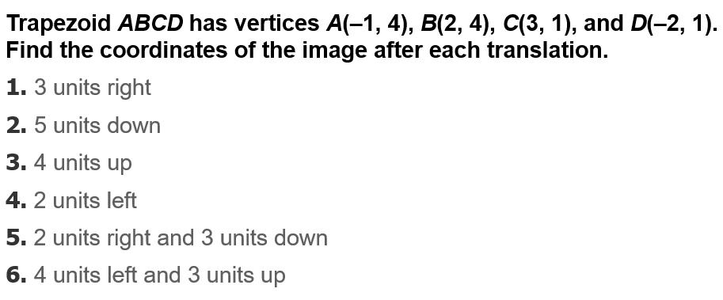

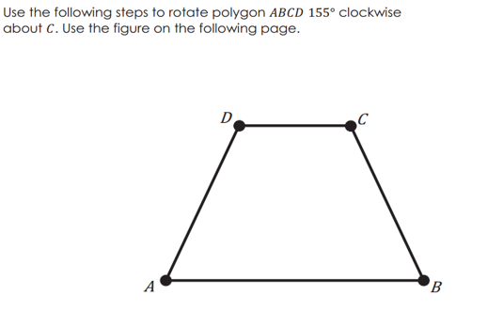
Example #A

Example #B  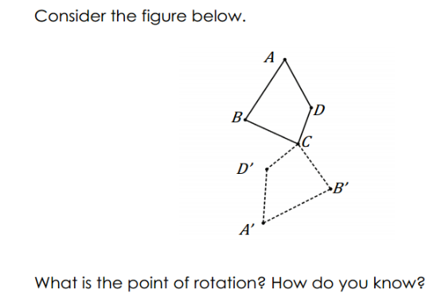 | 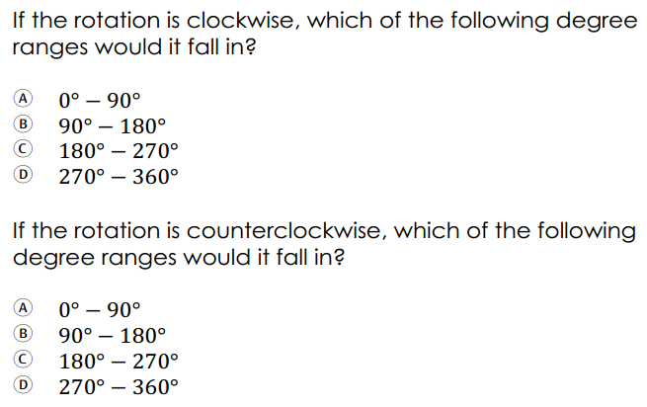

Example #1  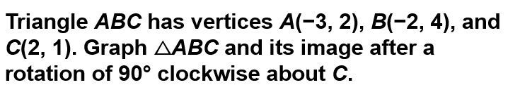 | 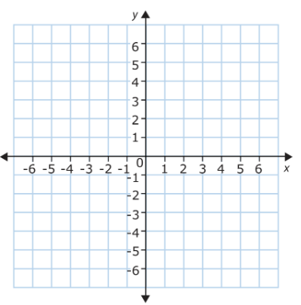
Example: 1A
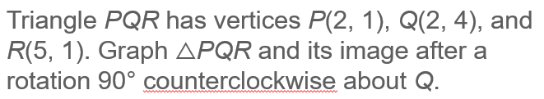

Example: 2  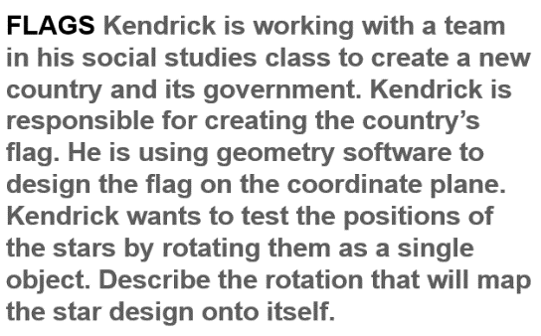 | 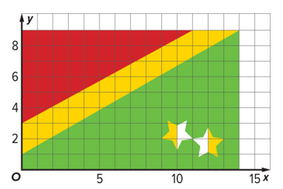

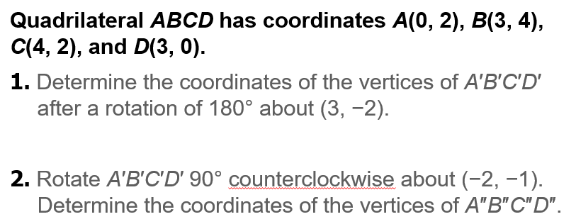
Exit Ticket

