Section 5-2 Congruent Triangles
Content Objective: Students will use congruence criteria and the Third Angles Theorem to solve problems.

Vocabulary: corresponding parts, congruent triangles, third angle theorem, reflexive property, symmetric property, transitive property

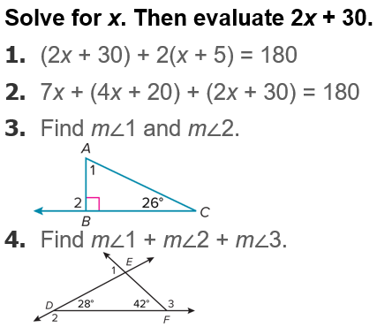
Warm up exercise

Example #1  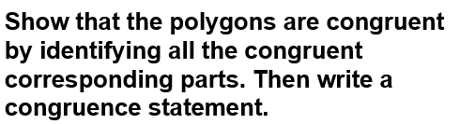 | 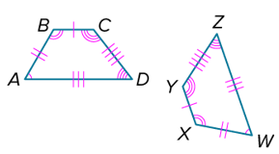

Example #2  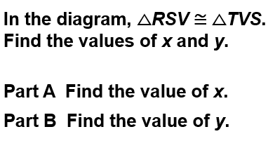 | 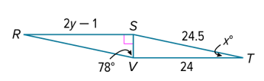

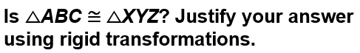  Example #3 | 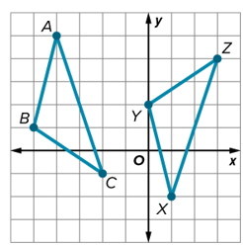
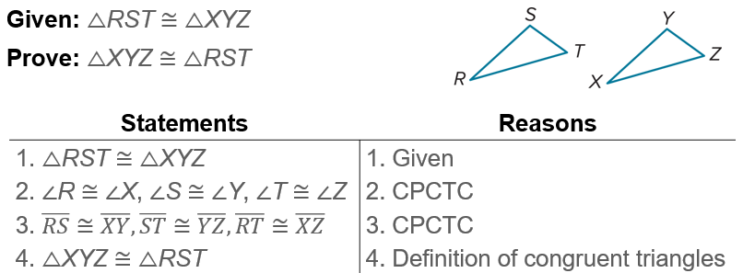
More Practice…

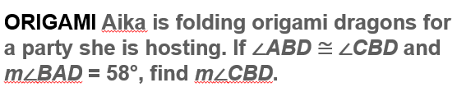  Example# 4 | 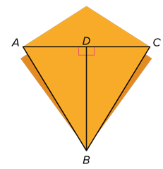

Example # 5
