Section 10-2 Measuring Angles and Arcs
Content Objective: Students find measures of angles and arcs in circles.

Vocabulary: central angle, arc, minor arc, major arc, semicircle, congruent arcs, adjacent arcs, intercepted arc, arc length, radian
Warm up exercise
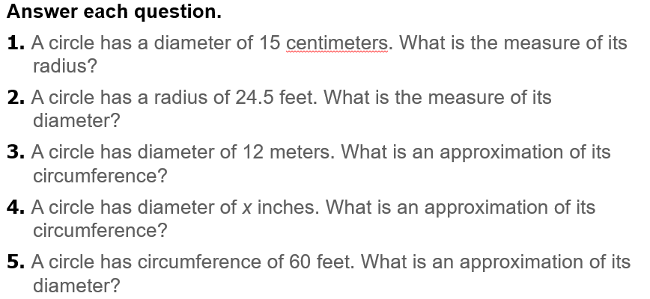

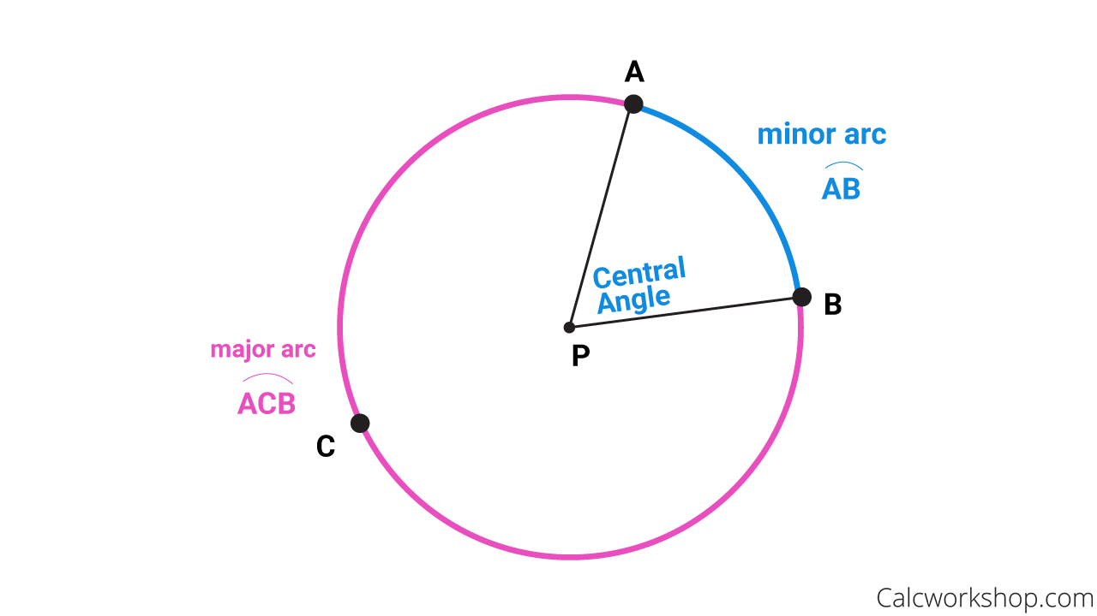  Notes… | 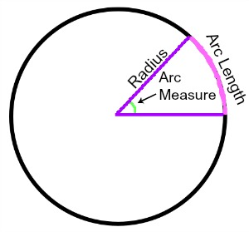
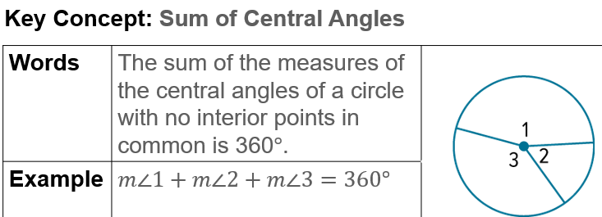 | 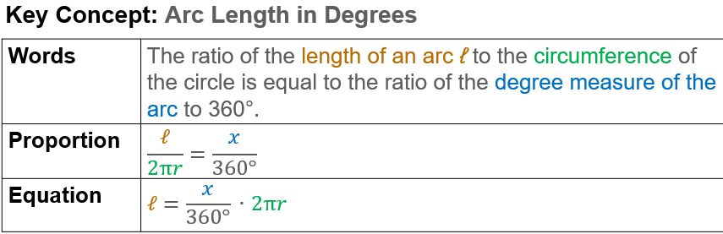
Example #1   | 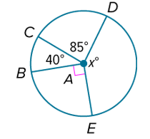

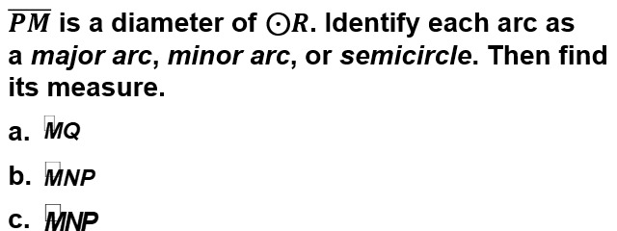  Example #2 | 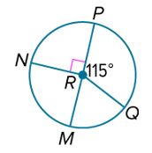

  Example #3 | 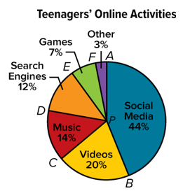

Example #4   | 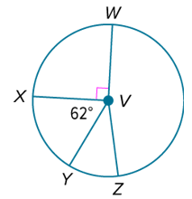

Example #5 | 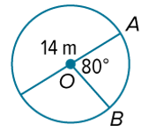

Example #6


Example #7

