Section 2-5 Three Dimensional Figures
Content Objective:
Students find surface area, volume, and missing measures of three-dimensional objects.

Vocabulary: polyhedron, prism, pyramid, cylinder, cone, sphere, regular polyhedron, platonic solids, surface area, volume, radius, diameter
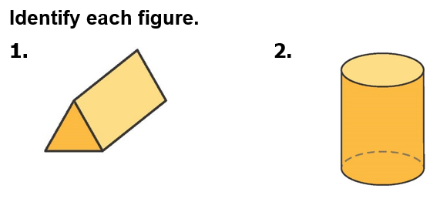  Warm up exercise | 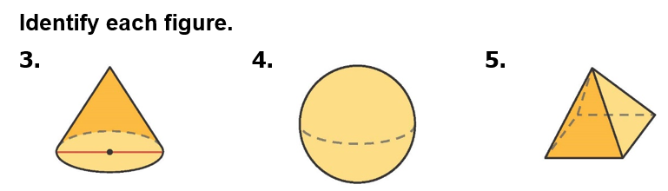

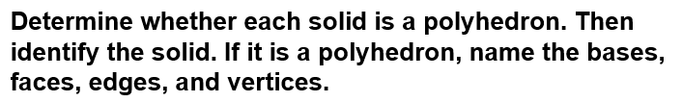  Example #1 | 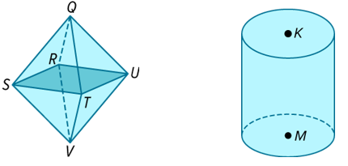

Example #2  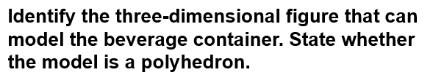 | 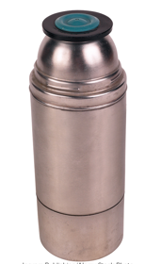

Example #3  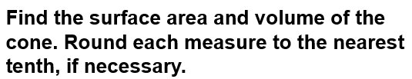 | 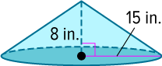

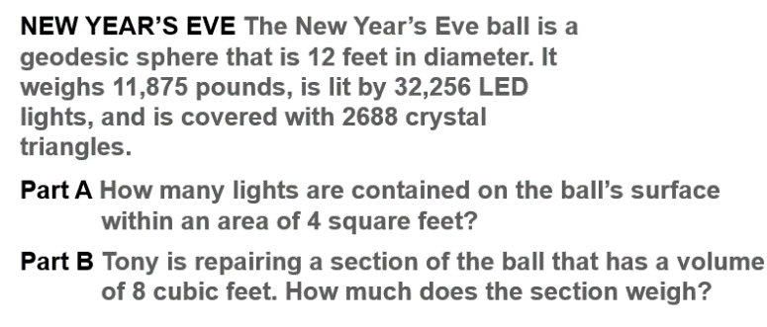  Example #4 | 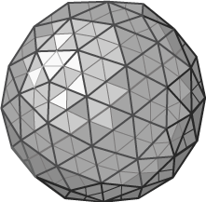

Example #5  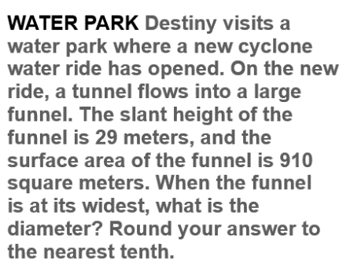 | 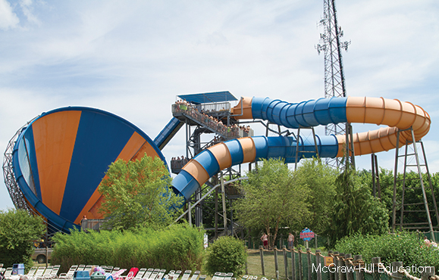

Exit Ticket  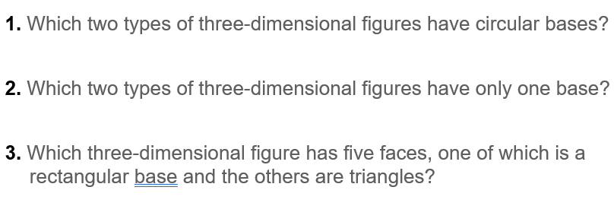 | 