Section 11-9 Density
Content Objective: Students solve real-world problems involving
density by using area and volume.

Vocabulary: Density, density based on area, density based on volume
Warm up exercise
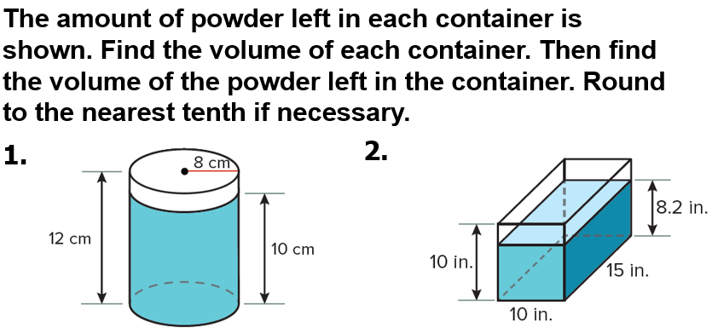

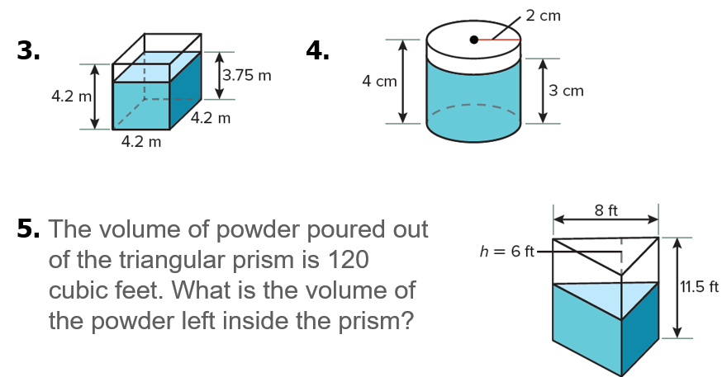

Notes…  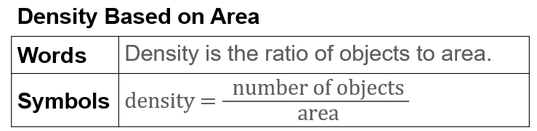 | 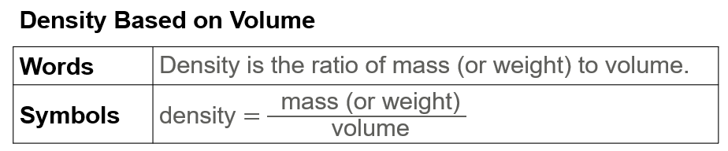
Example #1

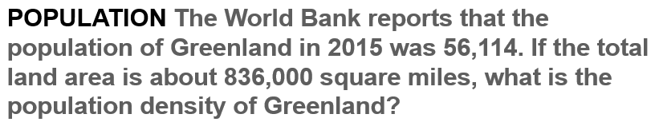

Example #2
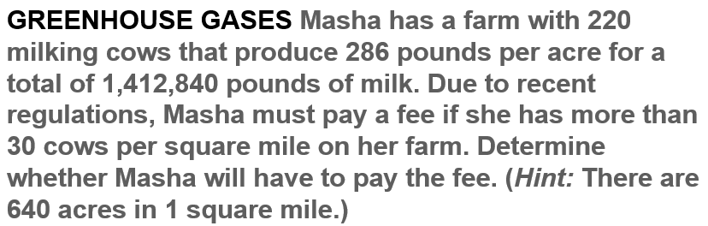

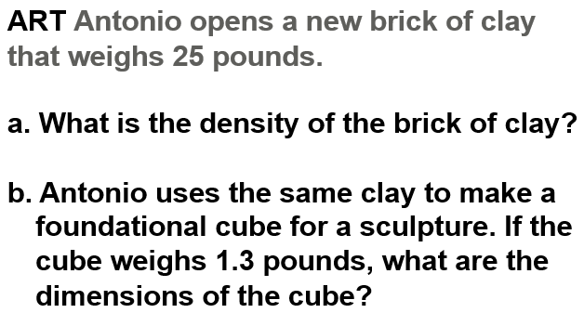  Example #3 | 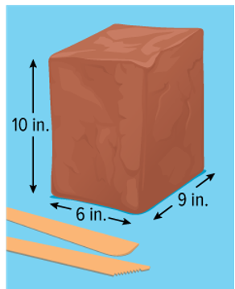
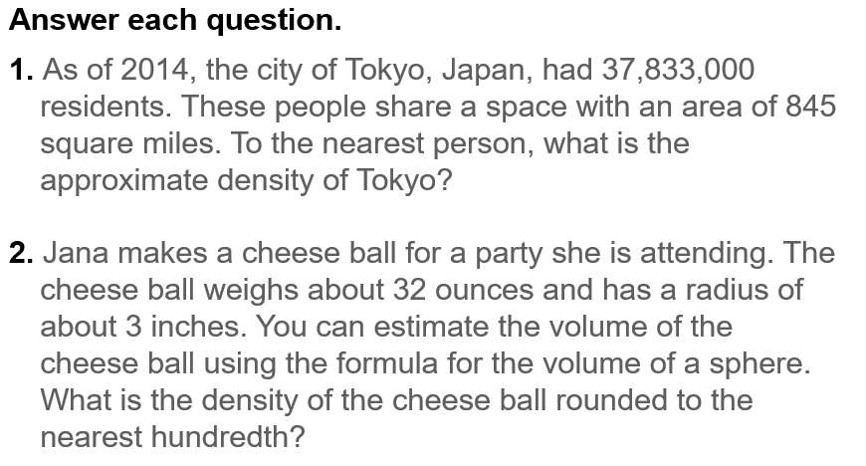
Exit Ticket…

