Section 2-4 Transformations in the Plane
Content Objective:
Students identify transformations and represent reflections, translations, and rotations.

Vocabulary: transformation, preimage, image, rigid transformations, reflection, translation, rotation, center of rotation, translation vector, transformation rules, angle of rotation,
Warm up exercise
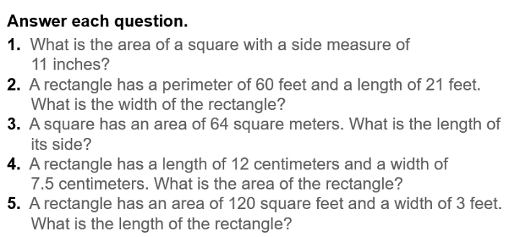

Example #1  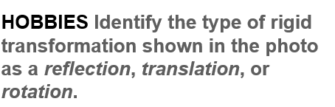 | 

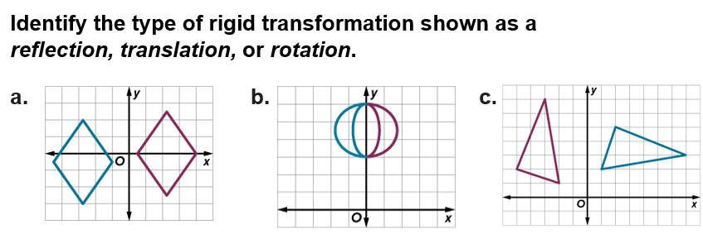
Example #2

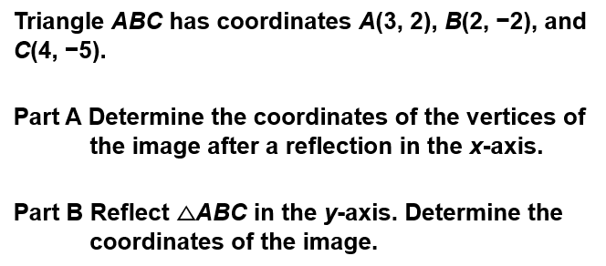  Example #3 | 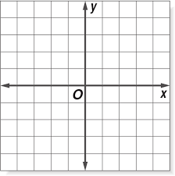

Example #4
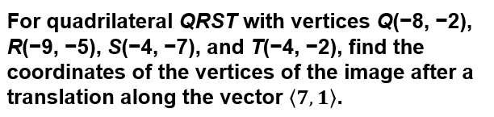

Example #5
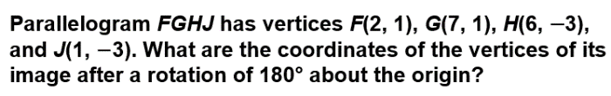

Exit Ticket  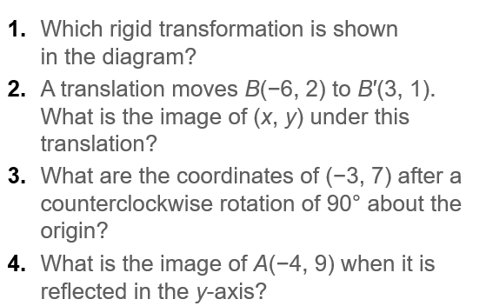 | 