Section 8-3 Similar Triangles – AA Similarity
Content Objective: Students use the AA similarity criterion to solve problems and prove triangles similar.

Vocabulary: AA similarity criterion, similar triangles
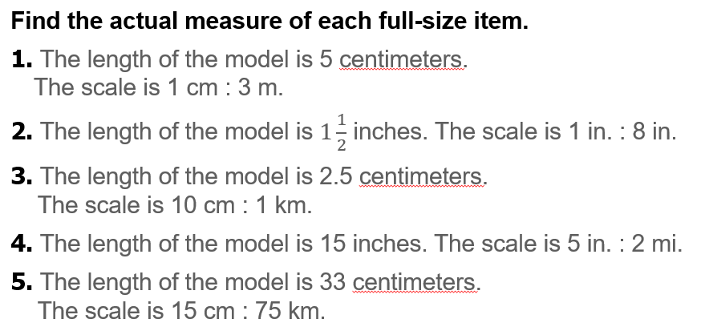
Warm up exercise

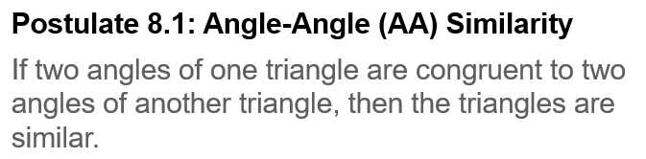
Notes…

  Example #1A | 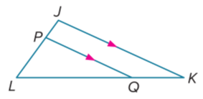

Example #1B |  | 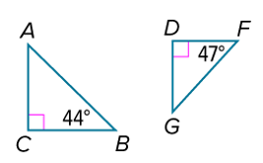
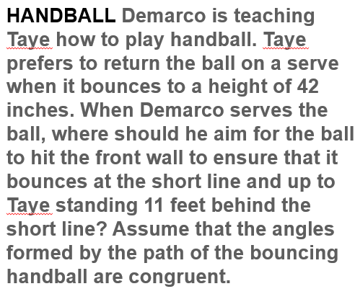  Example #2 | 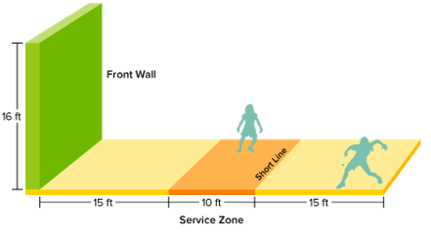

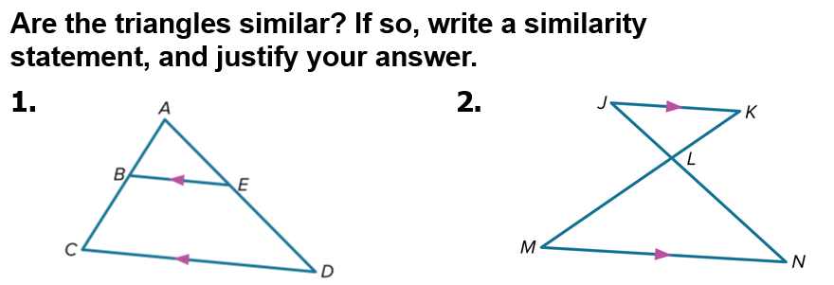
Exit Ticket

