Section 3-10 Perpendicular and Distance
Content Objective: Student will use perpendicular lines to find the distance

Vocabulary: Perpendicular lines, equidistant

Example #1  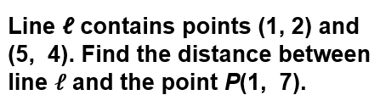 | 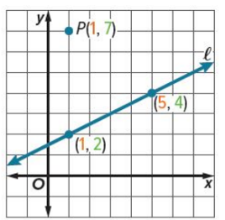

Example #1a  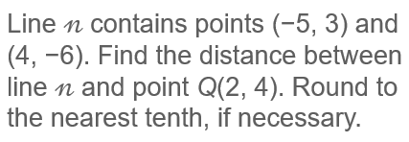 | 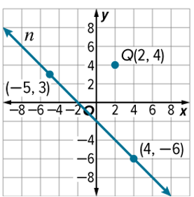

Example #2  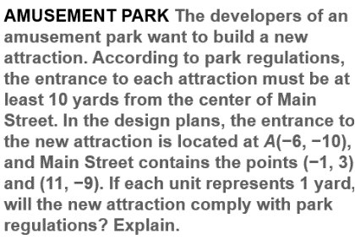 | 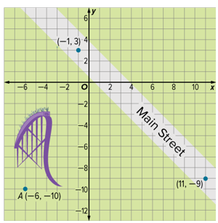

Example #3

