Section 4-4 Compositions Transformations
Content Objective: Students will determine the image of a figure after a composition of transformations on the coordinate plane and describe the composition of transformations that maps one figure onto other.

Vocabulary: composition transformations, glide reflections, composition of isometries theorem, reflection of parallel lines theorem, reflections of intersecting lines theorem

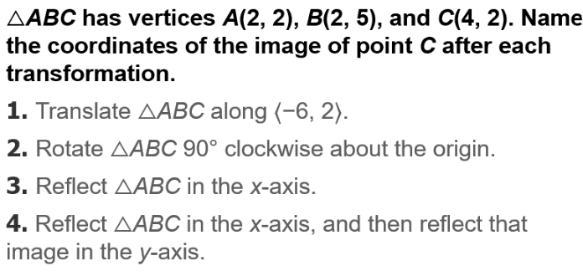
Warm up exercise

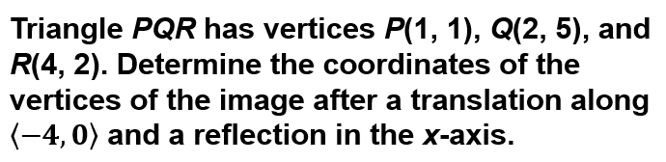  Example #1 | 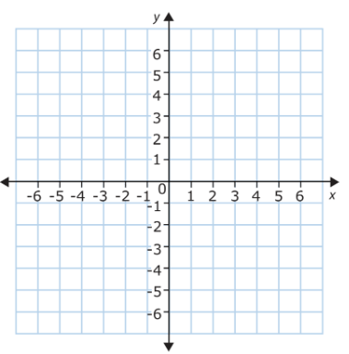

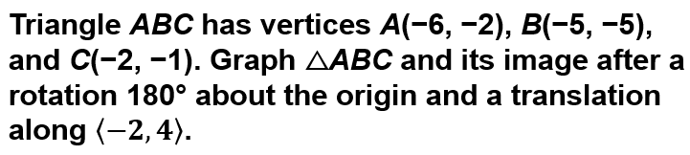
Example #2

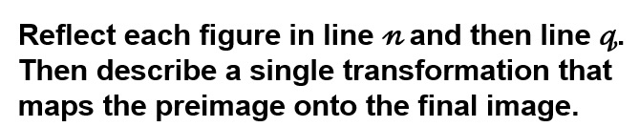  Example #3A | 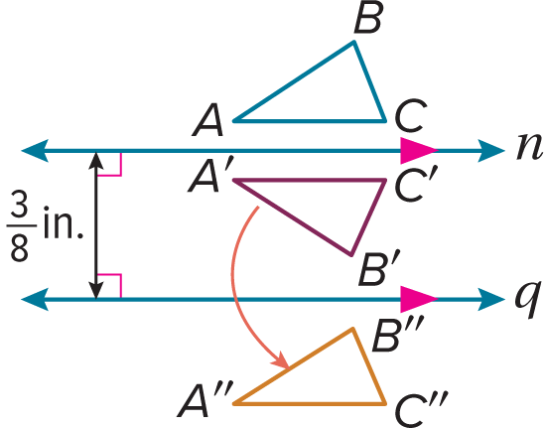
Example: 3B | 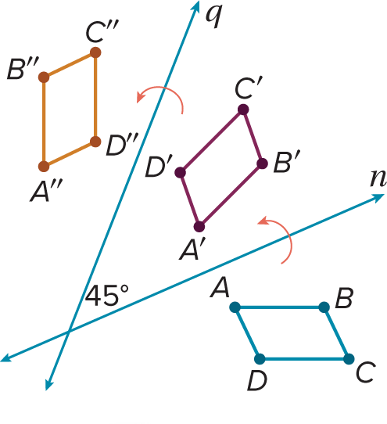

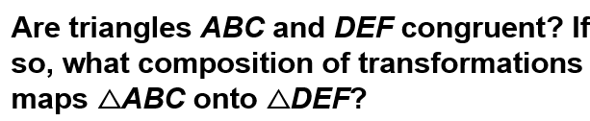  Example: 4 | 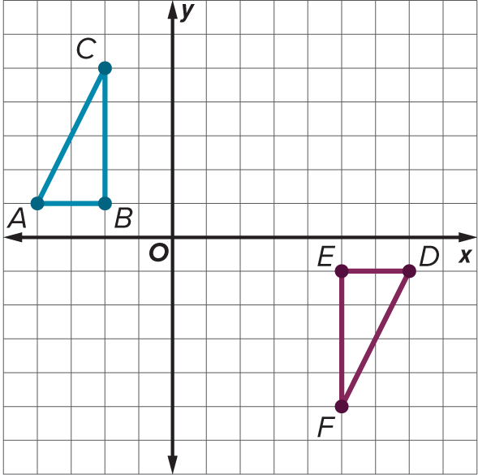
Exit Ticket
