Section 5-6 Isosceles and Equilateral Triangles
Content Objective: Students will solve problems involving isosceles and equilateral triangles.

Vocabulary: Isosceles triangle theorem, converse of isosceles triangle theorem, auxiliary line,

Warm up exercise  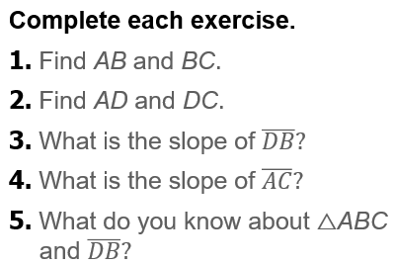 | 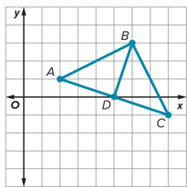

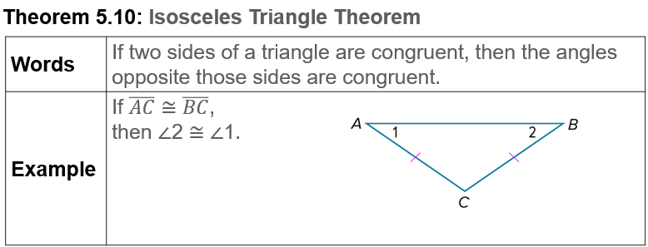
Notes…

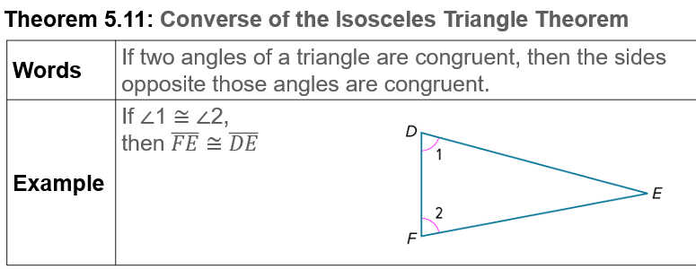
Notes…

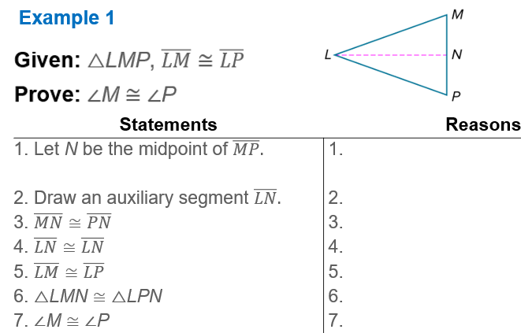

Example #2  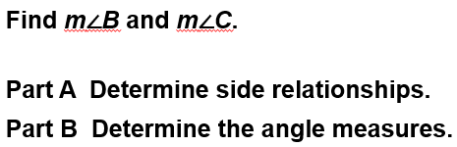 | 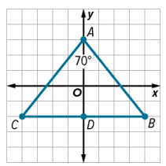

Example #3   | 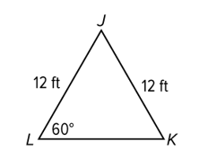

Example #4   | 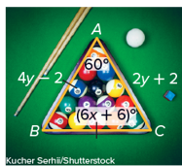

Exit Ticket…
