Section 6-1 Perpendicular Bisectors
Content Objective: Students solve problems using perpendicular bisectors in triangles.
Vocabulary: perpendicular bisector theorem, converse of perpendicular bisector theorem, concurrent lines, point of concurrency, circumcenter theorem,

Warm up exercise    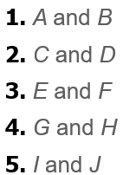 | 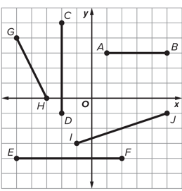

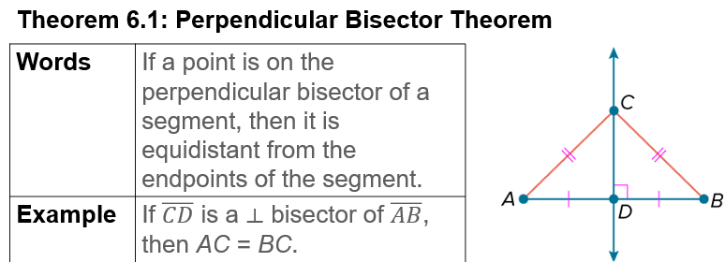
Notes…

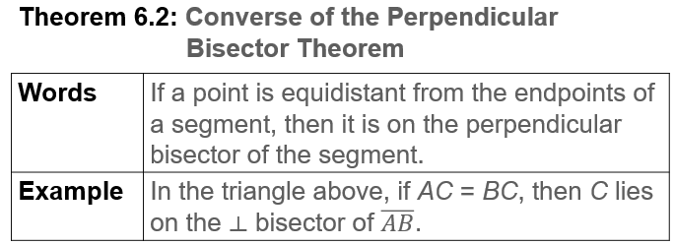  Notes… | 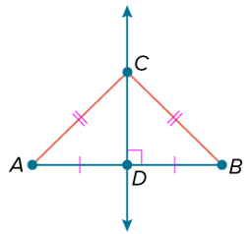

Example #1   | 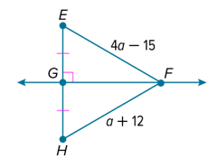

  Example #2 | 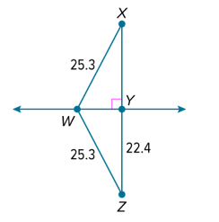

Example #3  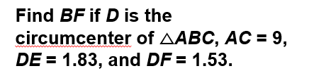 | 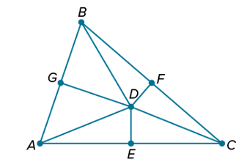

Example #4   | 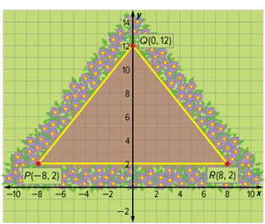

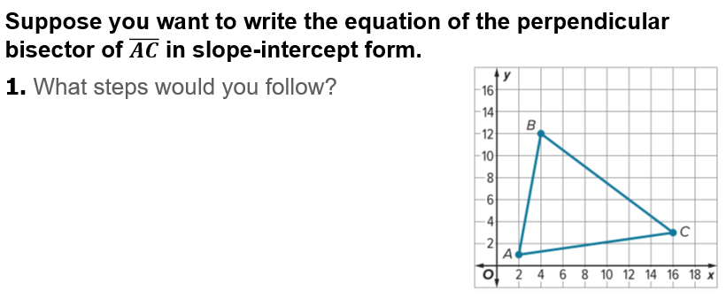
Exit Ticket…

