Section 11-2 Areas of Regular Polygons
Content Objective: Students find areas of regular polygons.

Vocabulary: regular polygon, apothem, central angle of regular, composite figures
Warm up exercise  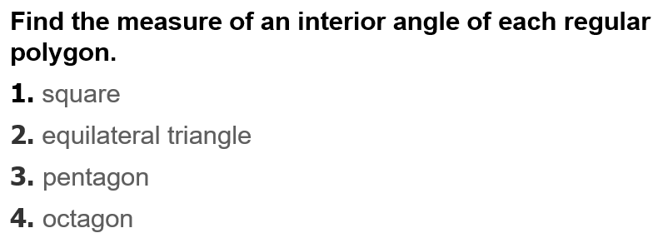 | 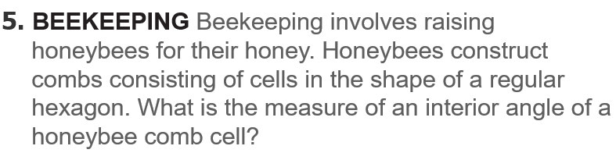

Notes…
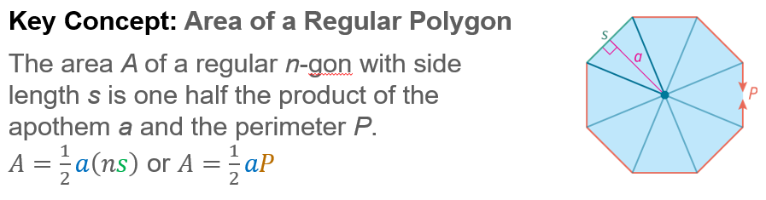

Example #1  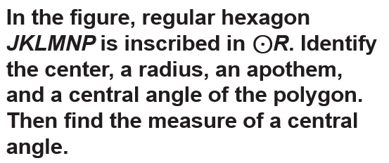 | 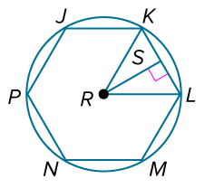

  Example #2 | 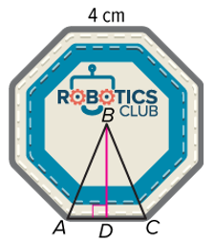

Example #3 | 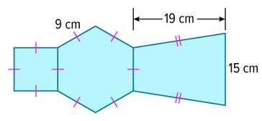

  Example #4 | 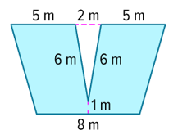

Exit Ticket…
