Section 8-5 Triangle Proportionality
Content Objective: Students use triangle proportionality to solve problems and prove theorems.
Vocabulary: Triangle proportionality theorem, Triangle Midsegment Theorem, Proportional Parts of Parallel lines, congruent parts of parallel lines
Warm up exercise
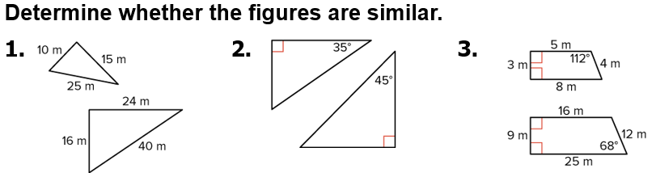

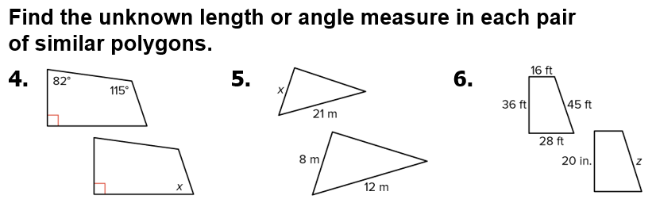

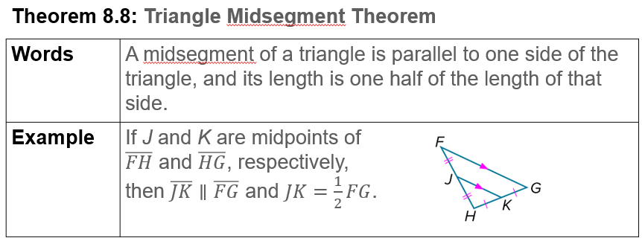  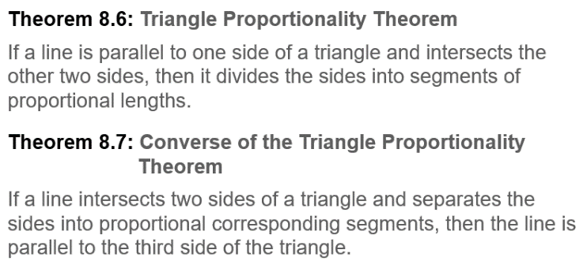  Notes… | 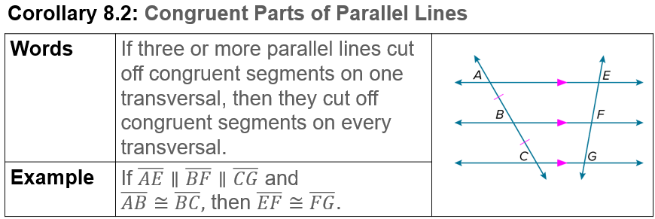  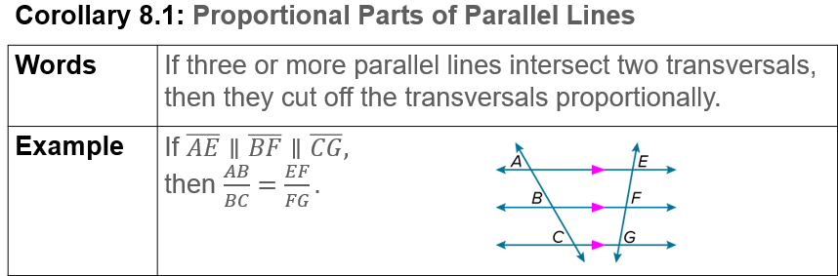

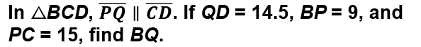  Example #1 | 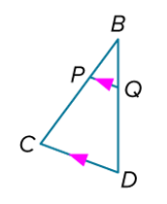

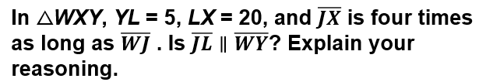  Example #2 | 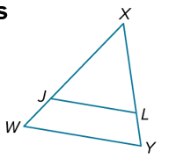

Example #3  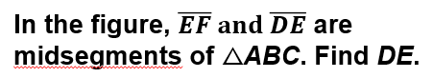 | 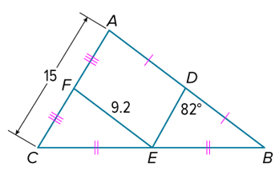

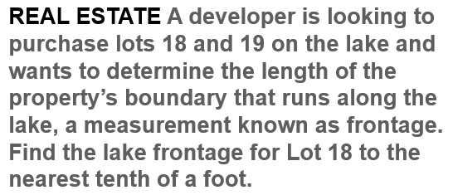  Example #4 | 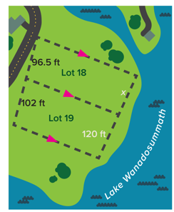

Example #5   | 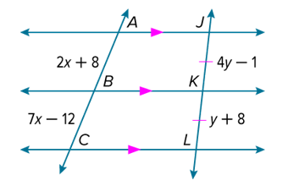

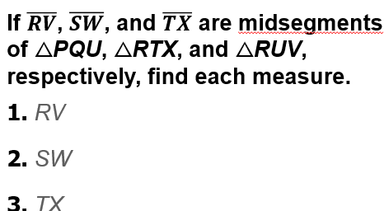  Exit Ticket | 