Section 8-4 Triangle Similarity SSS and SAS
Content Objective: Students use the SSS and SAS Similarity criteria to solve problems and prove triangles similar.

Vocabulary: SSS similarity, SAS similarity

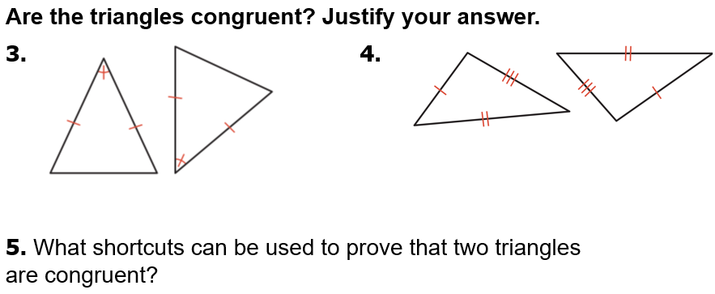
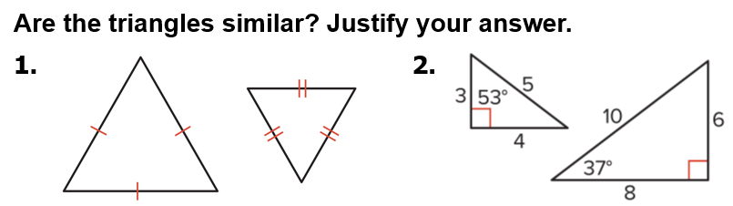
Warm up exercise

Notes…
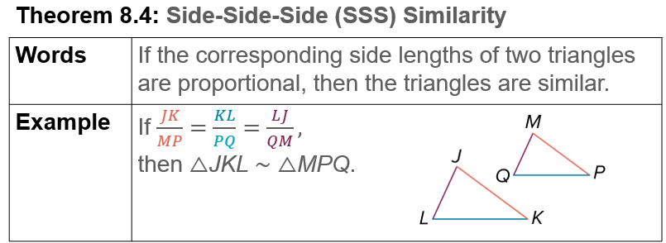

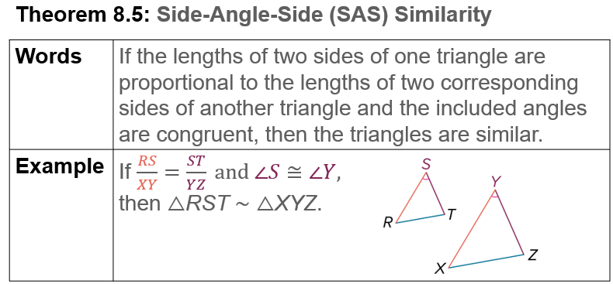

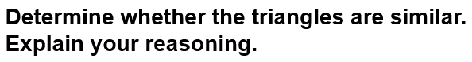  Example #1A | 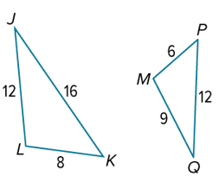

Example #1B | 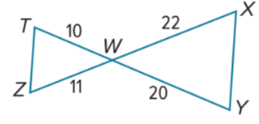

Example #2A | 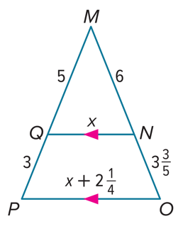

Example #2B   | 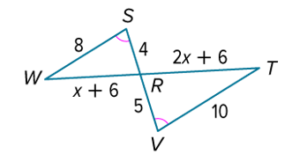

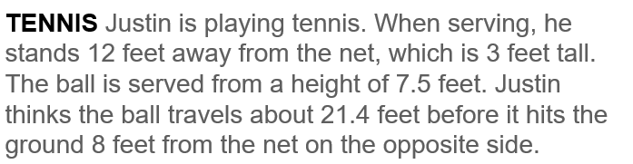  Example #3 | 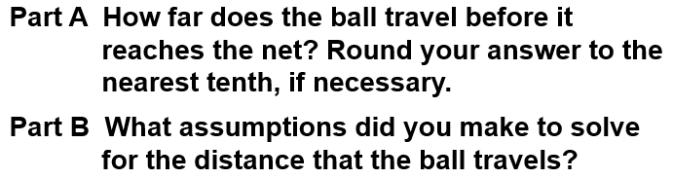

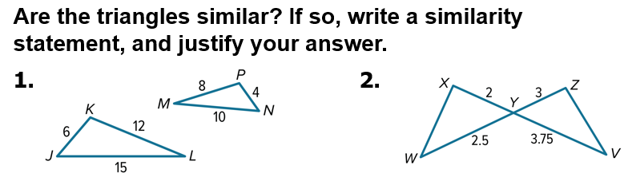  Exit Ticket… | 