Section 11-1 Areas of Quadrilaterals
Content Objective: Students find areas of quadrilaterals.

Vocabulary: Decomposition, area addition postulate, Area of rhombus and kites,
Warm up exercise
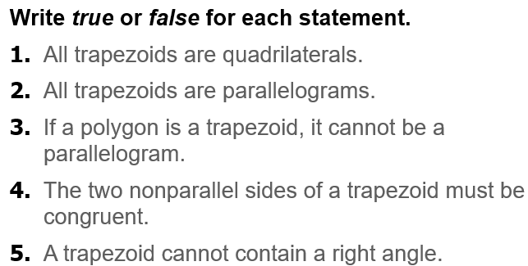

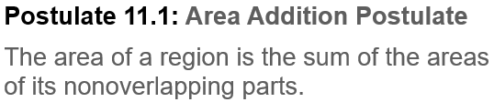  Notes…  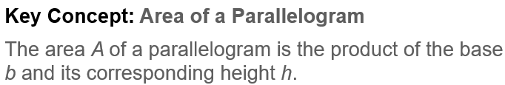 | 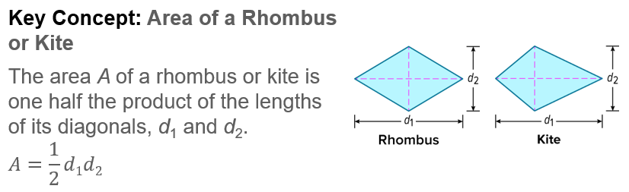  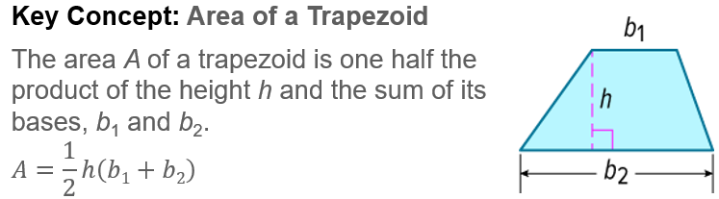
Example #1 | 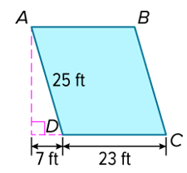
Example #2   | 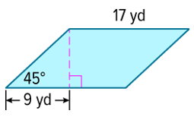

  Example #3 | 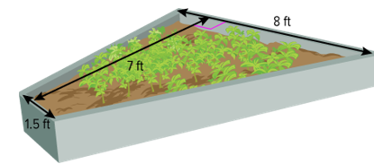

Example #4   | 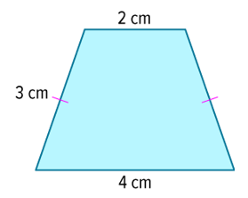

Example #5   | 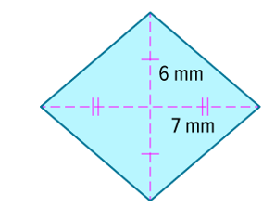

Example #6   | 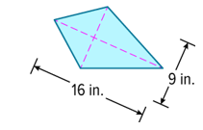

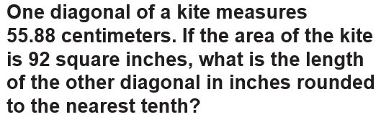  Example #7 | 