Section 11-3 Area of Circles and Sectors
Content Objective: Students find areas of circles and sectors.

Vocabulary: area of a circle, area of a sector
Warm up exercise
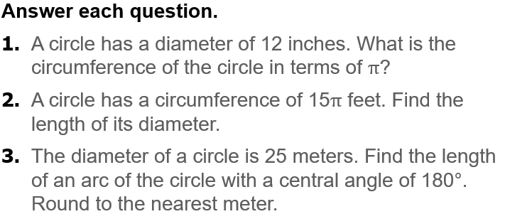

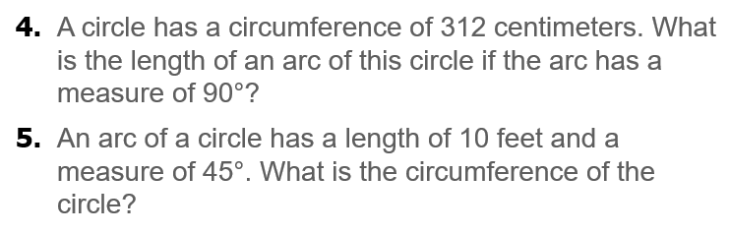

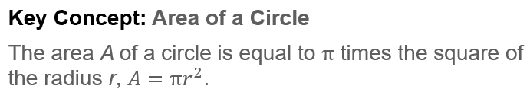  Notes… | 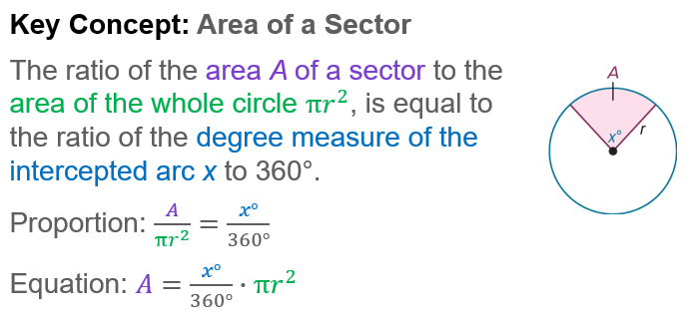
Example #1  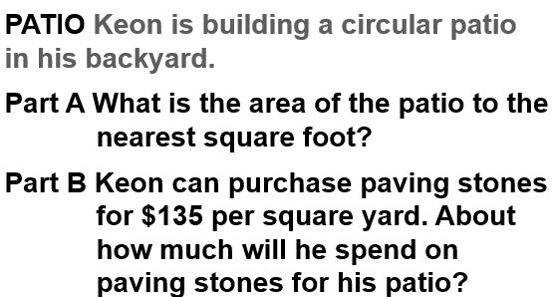 | 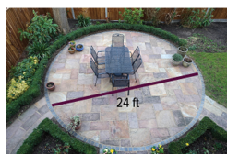

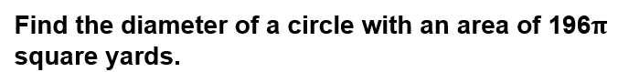
Example #2

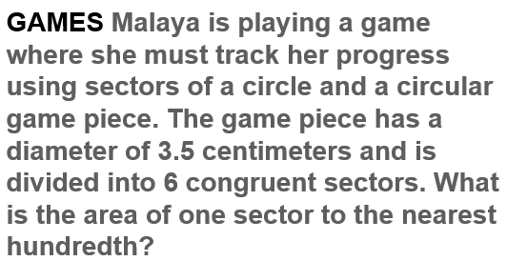  Example #3 | 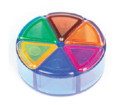

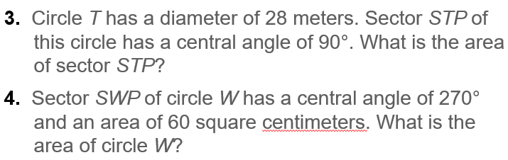
Exit Ticket…
