Section 1-4 Midpoints and Bisectors
Content Objective:
Students will find midpoints and bisect line segments.

Vocabulary: midpoint, equidistant, bisects, segment bisector
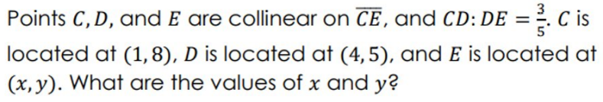  Warm up exercise | Warm up exercise  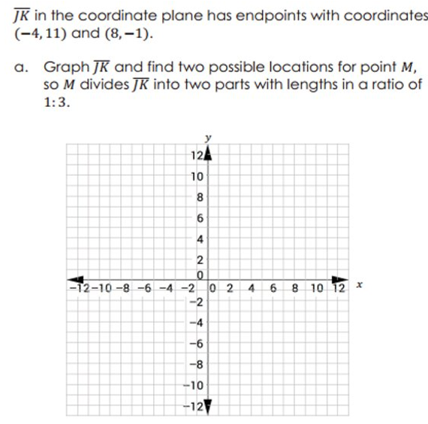

Example #1 | 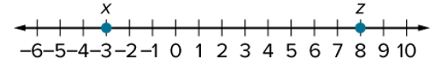

Example #2  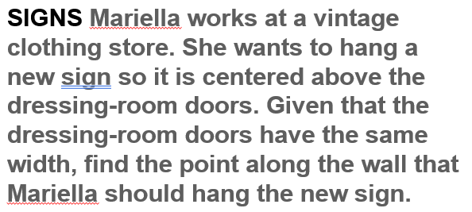 | 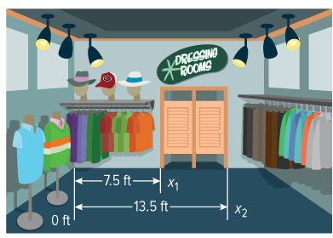

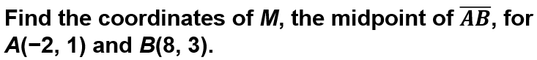
Example #3

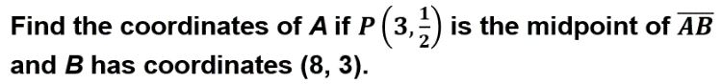
Example #4

Construction:  Segment Bisector | 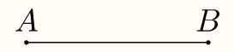

Example #5   | 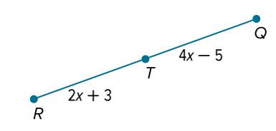

Example #6   | 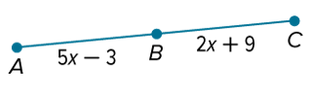

Exit Ticket        