Section 2-1 Angles and Congruence
Content Objective:
Students identify and use angles, angle parts, and special angle pairs.

Vocabulary: ray, opposite rays, straight angle, angle, sides of an angle, vertex, interior of an angle, exterior of an angle, congruent angles, copying an angle, angle bisector, adjacent angle, linear pair, vertical angles,
Warm up exercise
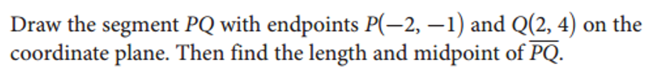

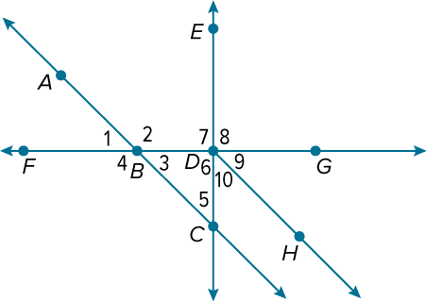  Example #1  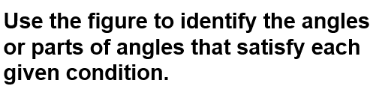 | 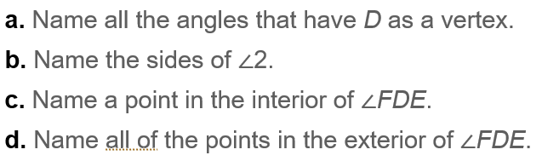

Example #2  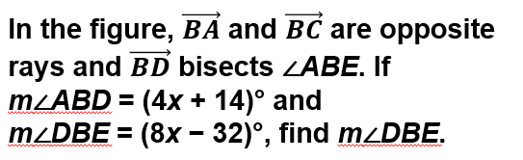 | 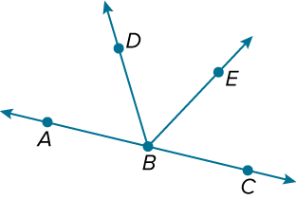

Example #3  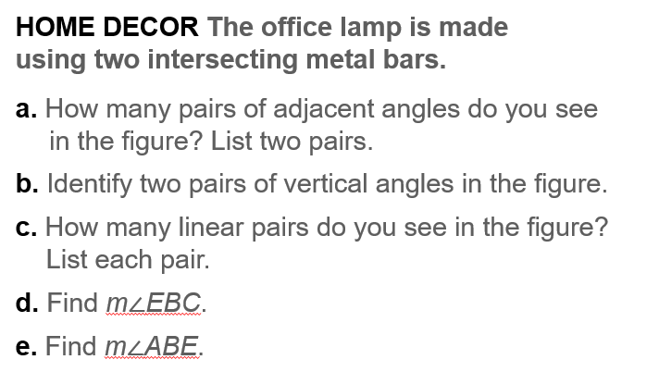 | 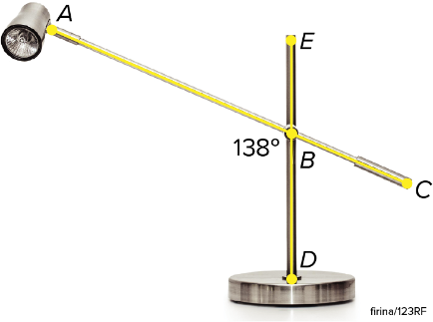

Example #4  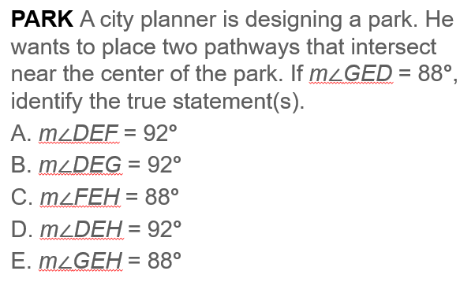 | 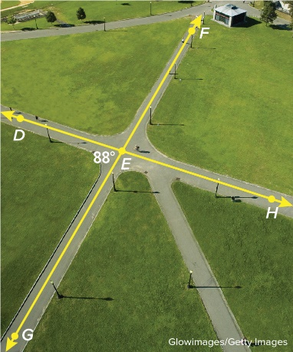

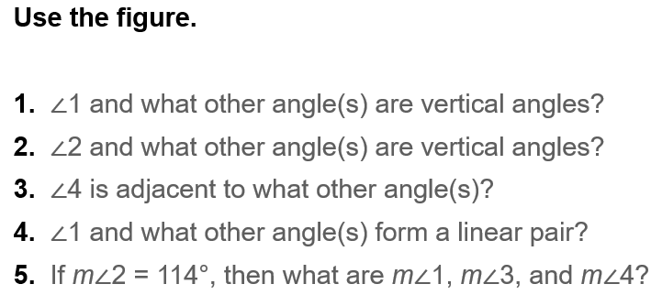  Exit Ticket | 