Section 7-5 Rhombi and Squares
Content Objective: Students apply and prove the properties of rhombi and squares.
Vocabulary: Rhombus, Square, Properties of Rhombi and Square

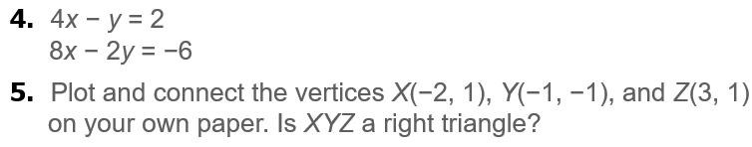
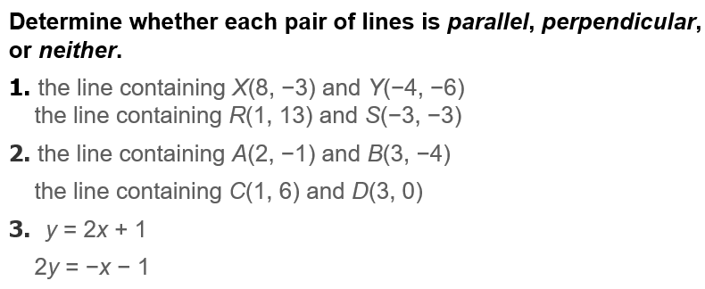
Warm up exercise

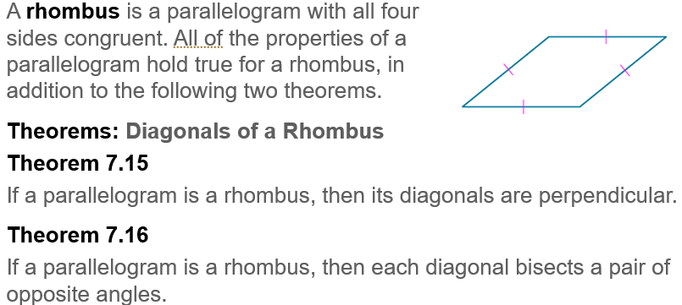  Notes… | 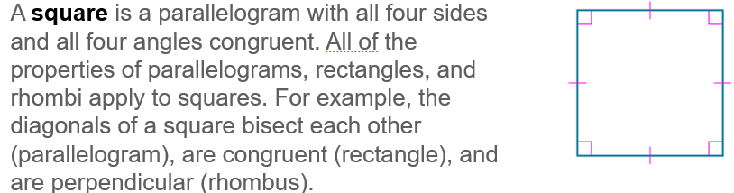

Example #1  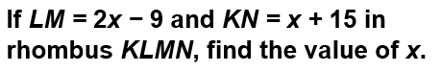 | 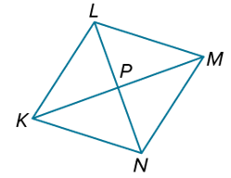

Example #2  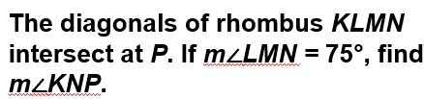 | 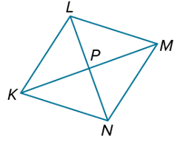

Example #3 | 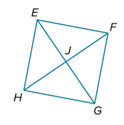

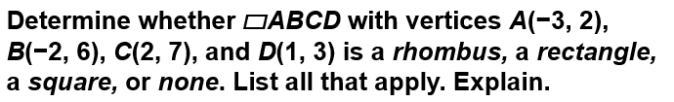  Example #6 | 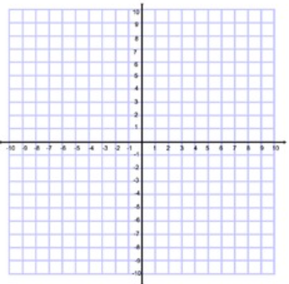

Exit Ticket
