Section 9-4 Applying Trigonometry
Content Objective: Students will solve real-world problems using the trigonometric ratios and their inverses. Students will find the area of triangles using a formula based on the sine function.

Vocabulary: indirect measurement, angle of elevation, angle of depression,
Warm up exercise
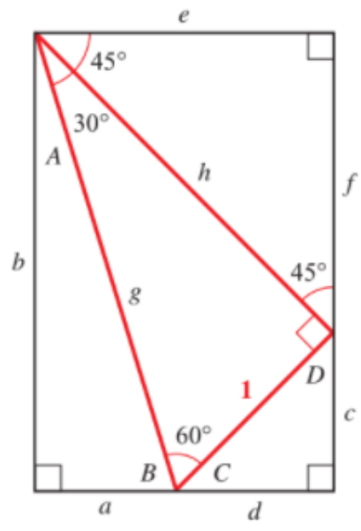
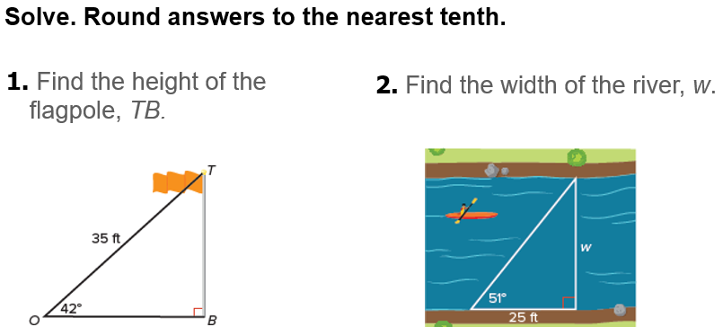

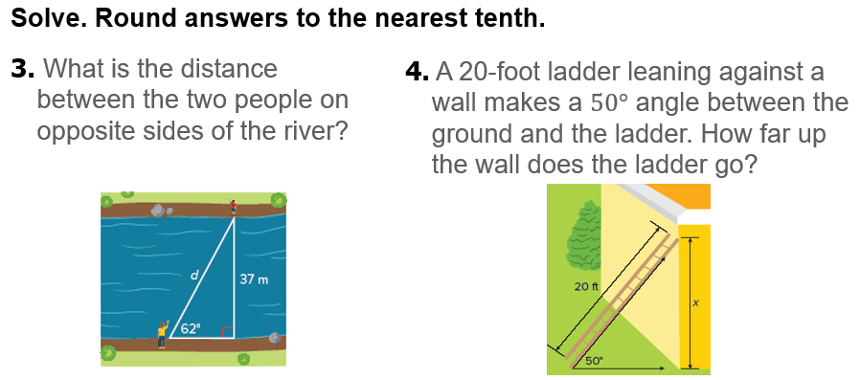

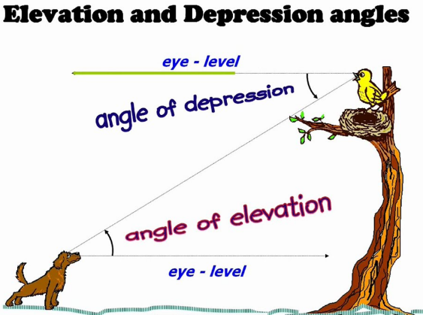
Notes…

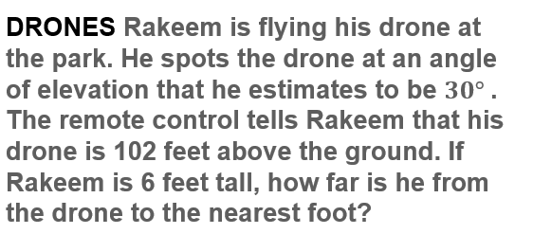  Example #1 | 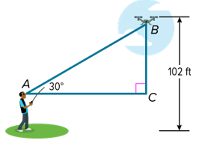

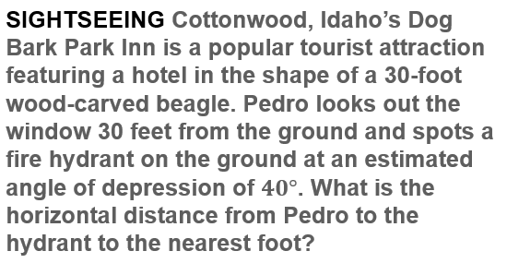  Example #2 | 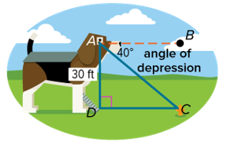

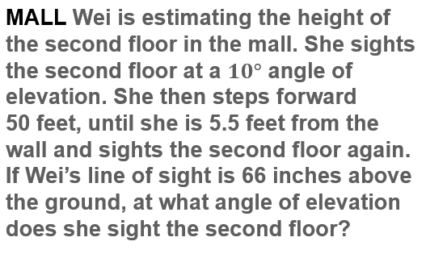  Example #3A | 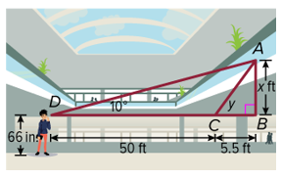

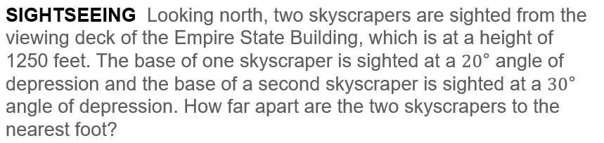
Example #3B

Exit Ticket
