Section 6-6 Triangle Inequality
Content Objective: Students prove and apply the Triangle Inequality Theorem.
Vocabulary: triangle inequality theorem

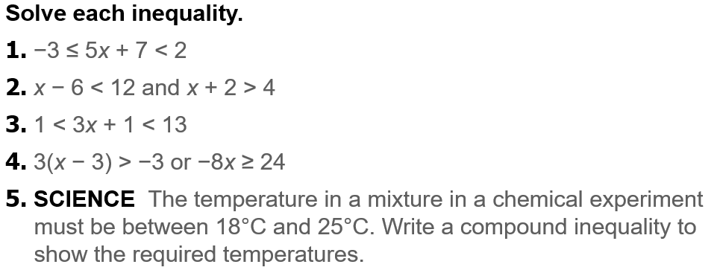
Warm up exercise

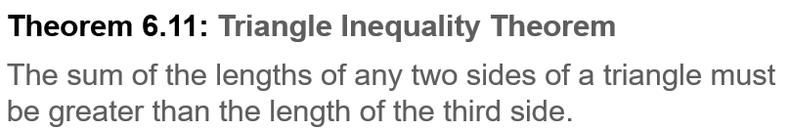
Notes…

Example #1

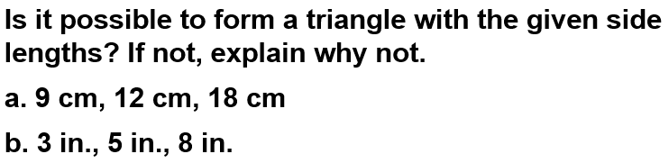

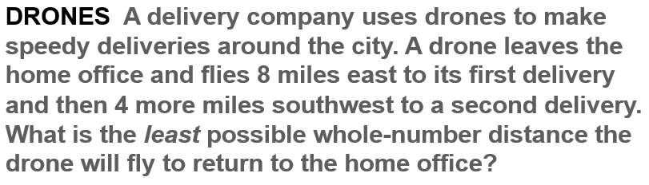
Example #2

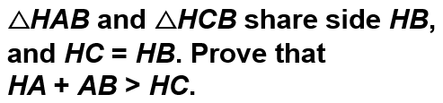  Example #3 | 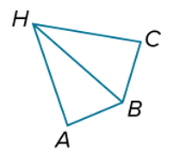

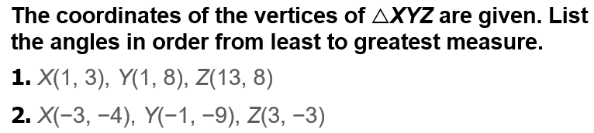  Exit Ticket… | 