Section 4-2 Translation
Content Objective: Students will use rigid transformations to translate figures on the coordinate plane and describe the effects of the translations.

Vocabulary: magnitude, rule (x,y) ----> (x + ___, y + ____)

Warm up exercise  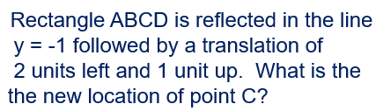 | 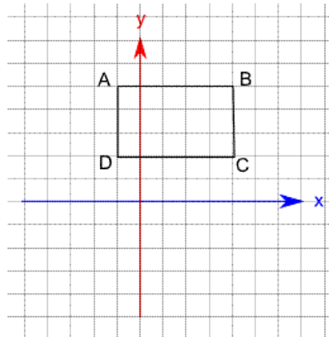

Example #1  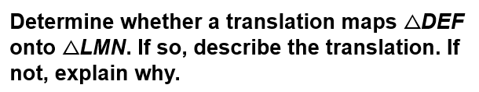 | 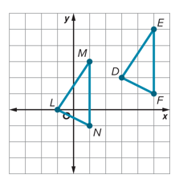

Example #1A  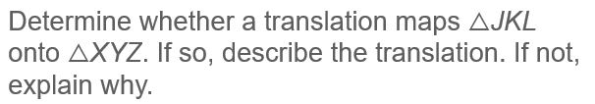 | 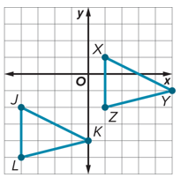

Example #2   | 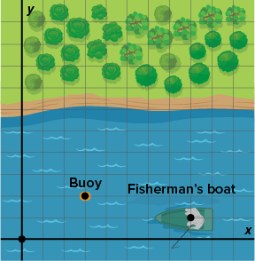

Exit Ticket  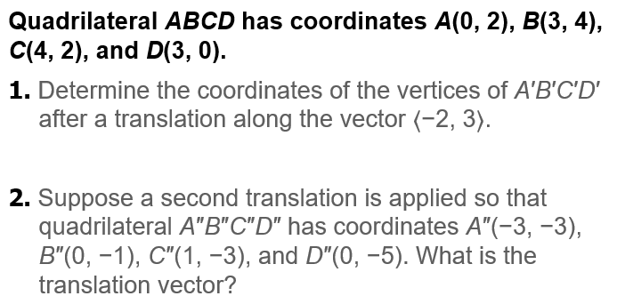 | 