Section 5-4 Proving Triangles Congruent ASA, AAS
Content Objective: Students will use ASA and AAS to prove triangles congruent.

Vocabulary: ASA congruence, AAS congruence, included angle

Warm up exercise
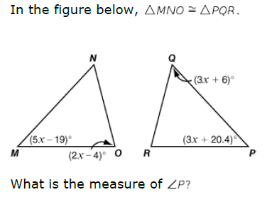

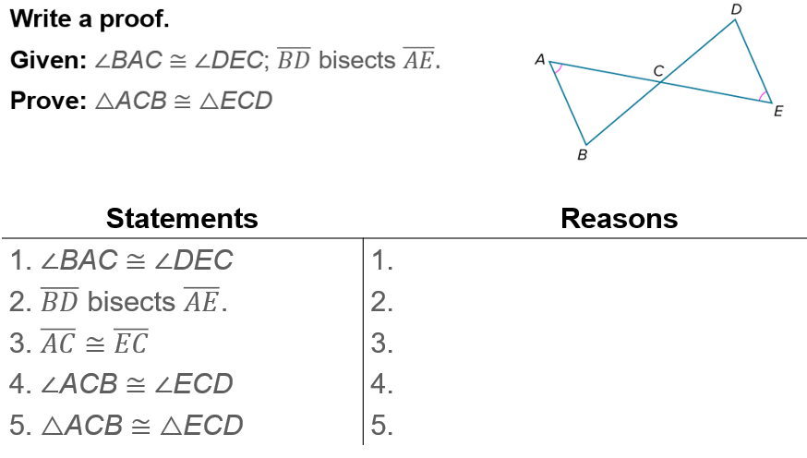
Example #1A

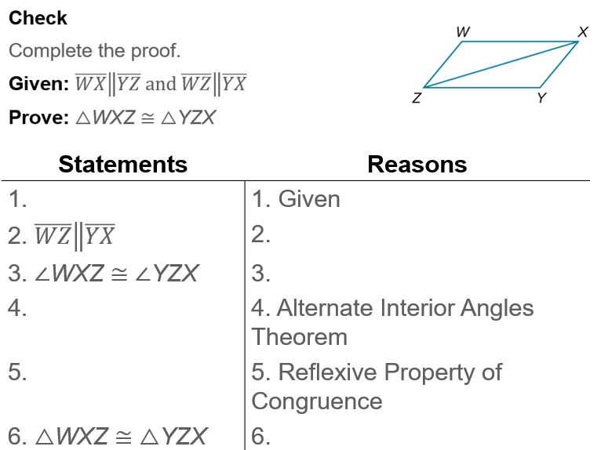
Example #1B

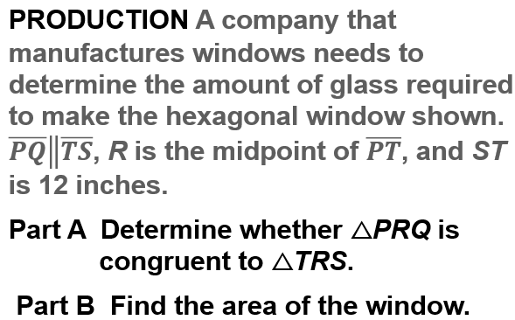  Example #2 | 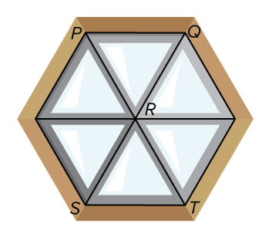
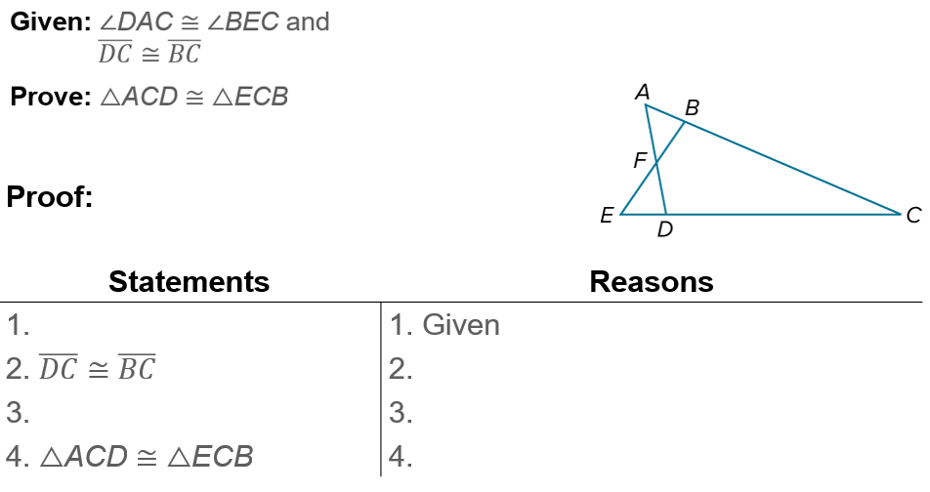
Example #

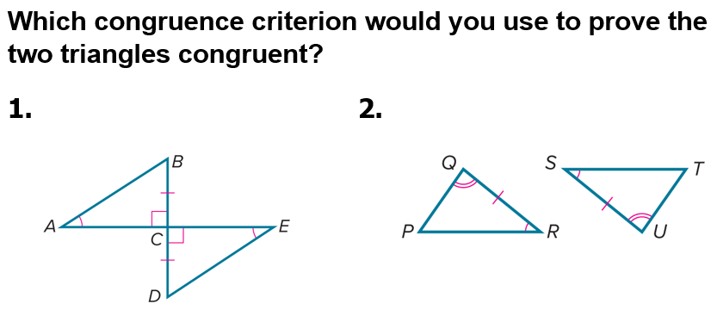
Exit Ticket…

