Section 4-1 Reflections
Content Objective
Students will use rigid transformations to reflect figures on the coordinate plane and describe the effects of the reflections.
Vocabulary: reflections over x-axis, y-axis, y = x, y =- x, reflections over vertical lines, horizontal lines

Warm up exercise  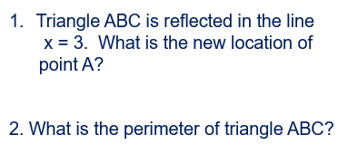 | 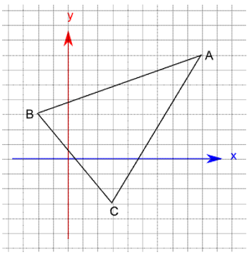

Example #1  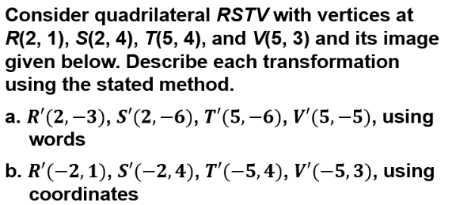 | 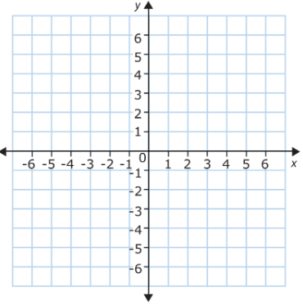

Example #1A  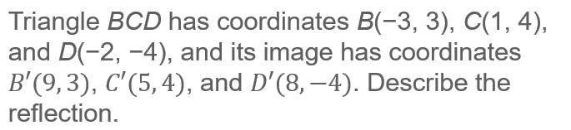 | 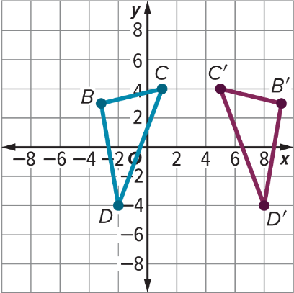

Example #2  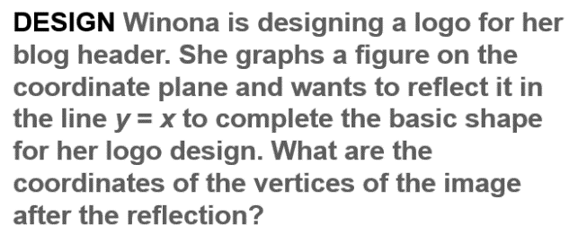 | 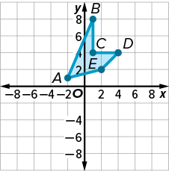

Example #3
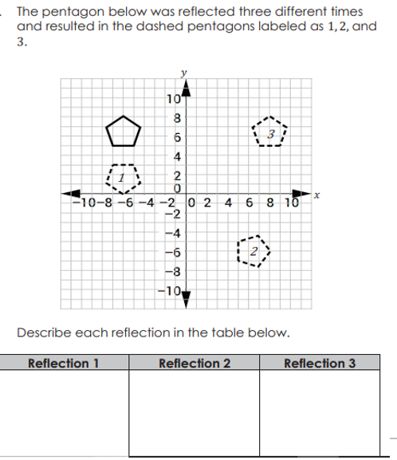

Example #4
