Section 10-3 Arcs and Chords
Content Objective: Students solve problems involving the relationship between arcs and chords, and radii that are perpendicular to chords.

Vocabulary: chord, congruent arcs, bisecting chords
Warm up exercise  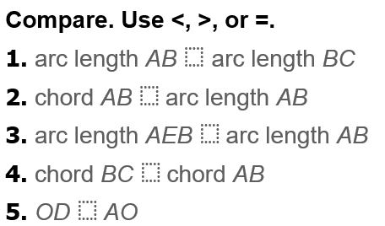 | 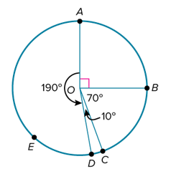

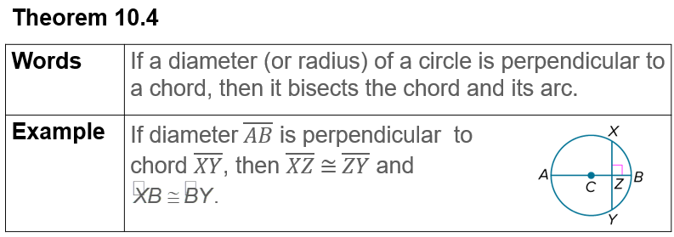  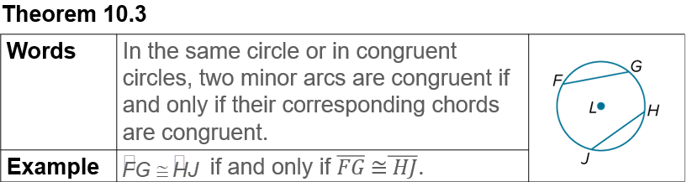  Notes | 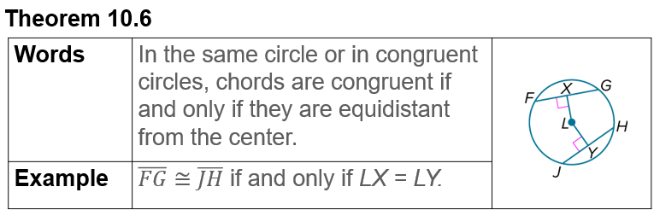  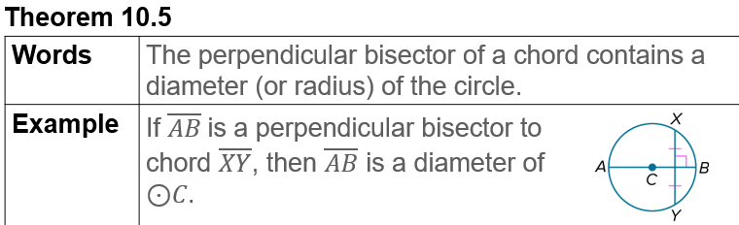

Example #1  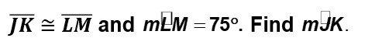 | 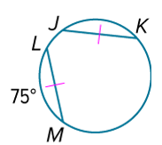
Example #2   | 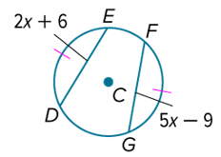

  Example #3 | 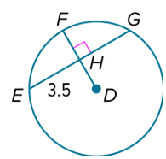

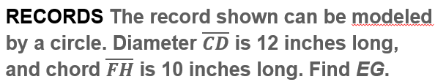  Example #4 | 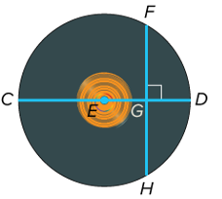

Example #5 | 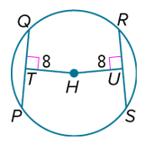

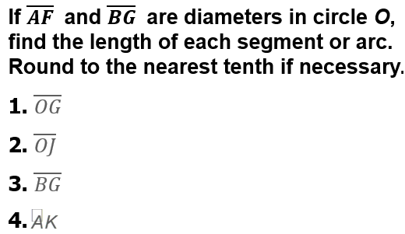  Exit Ticket | 