Section 4-5 Symmetry
Content Objective: Students will identify line and rotational symmetries
and identify transformations in tessellations.

Vocabulary: tessellation, regular tessellation, symmetry, line symmetry, rational symmetry, center of symmetry, order of symmetry, magnitude of symmetry, point of symmetry,

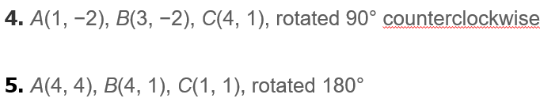
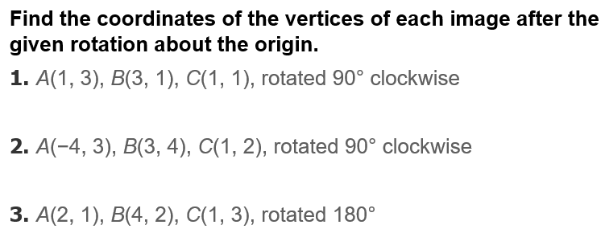
Warm up exercise

Example #1



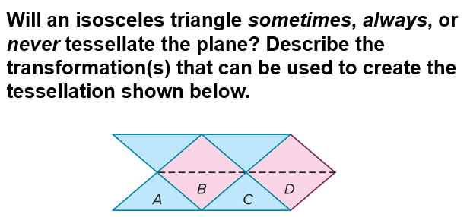
Example #2

Example #3   | 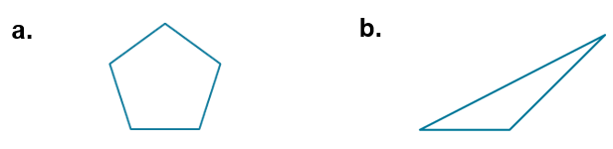
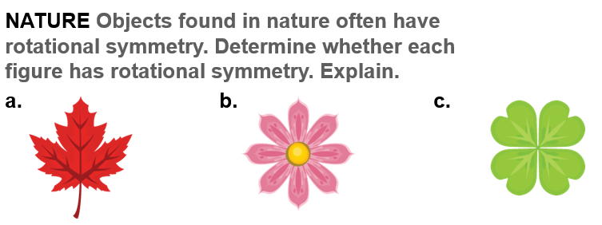
Example: 4

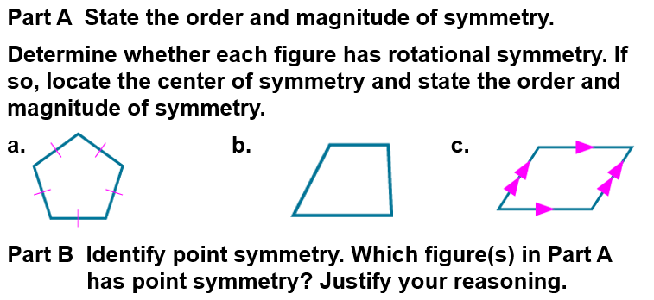
Example: 5
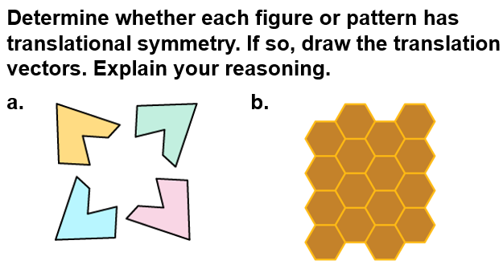
Example: 6

