Section 7-1 Angles of Polygons
Content Objective: Students use theorems about the interior and exterior angles of polygons to solve problems and then prove these theorems.

Vocabulary: Polygon Interior and Exterior Angles Sum Theorem

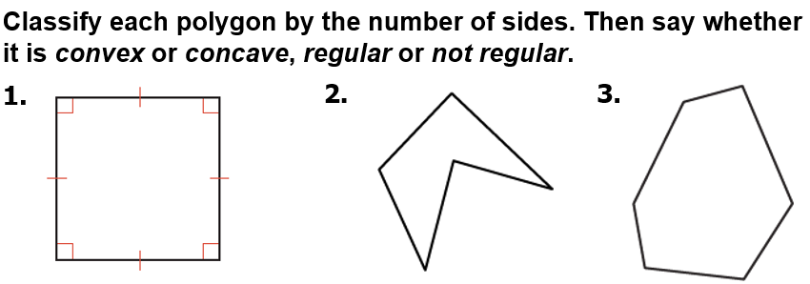
Warm up exercise

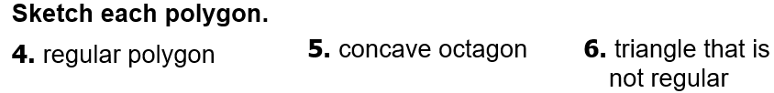

Notes…
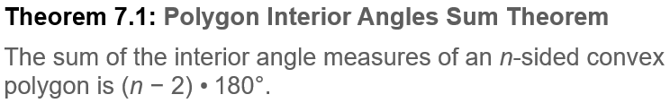

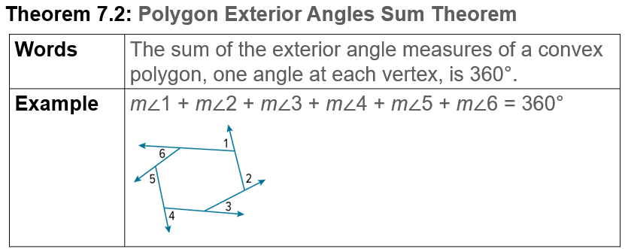

Example #1   | 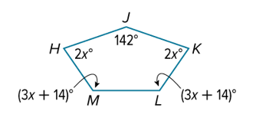

Example #2   | 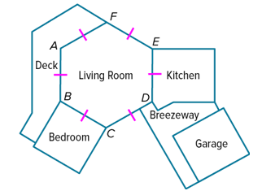

Example #3

Example #4   | 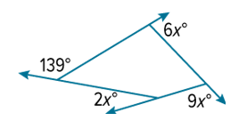


Example #5


Exit Ticket

