Section 3-5 Proving Segments Relationships
Content Objective: Students prove theorems about line segments.

Vocabulary: Segment Addition Postulate

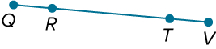  Example #1  Write a two-column proof.  Given: $\overline{QT}$ ≅ $\overline{RV}$  Prove: $\overline{QR}$ ≅ $\overline{TV}$ | 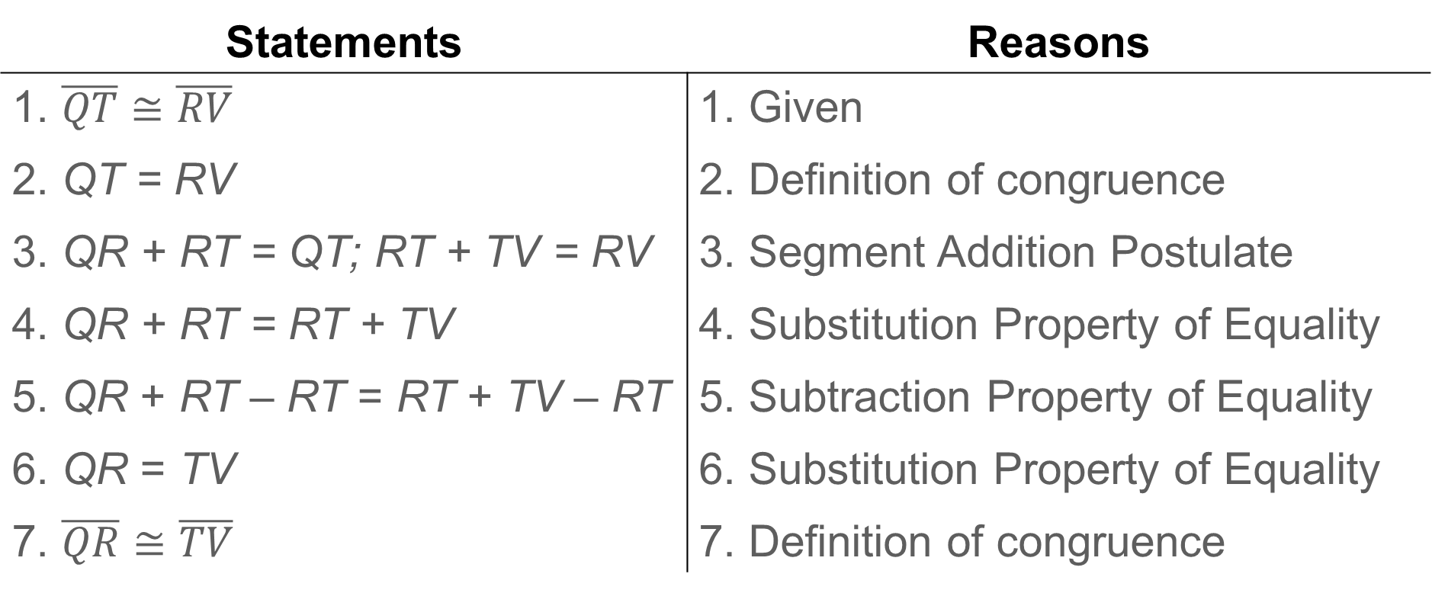

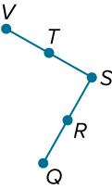  Example #2  Write a two-column proof.  Given: R is the midpoint of $\overline{QS}$.  T is the midpoint of $\overline{VS}$.  $\overline{QR}≅\overline{VT}$  Prove: $\overline{RS}≅\overline{VS}$ | 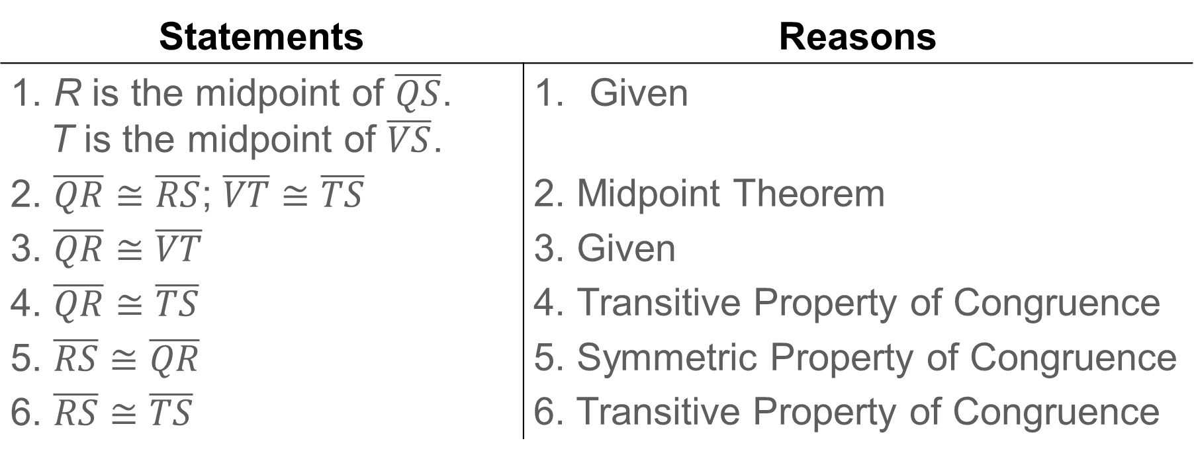

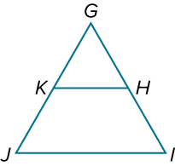
Example #3
Check
Complete the two-column proof.
Given: $\overline{GJ}≅\overline{GI}$
K is the midpoint of $\overline{GJ}$.
H is the midpoint of $\overline{GI}$.
Prove: $\overline{GK}≅\overline{GH}$

