Section 9-2A Special Right Triangles
Content Objective: Students will solve problems by using the properties of $45°-45°-90°$ triangles.
Vocabulary: 45-45-90 triangle

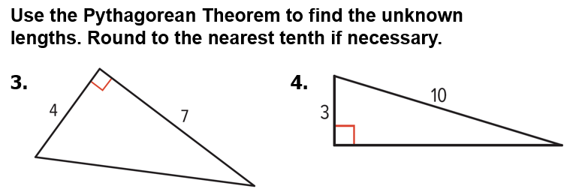
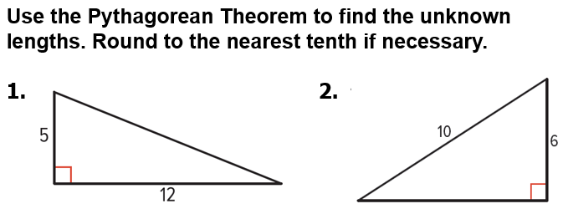
Warm up exercise

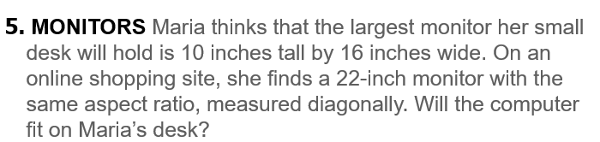

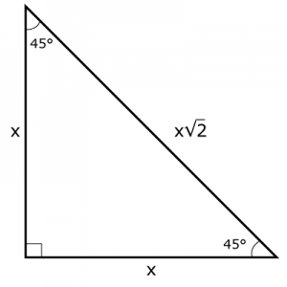
Notes…

45-45-90 triangle

Example #1A   | 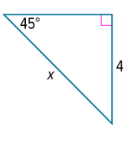
  Example #1B | 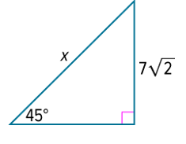

Example #2A   | 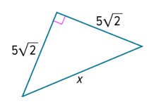

Example #2B   | 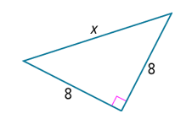

Example #3A | 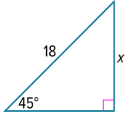

Example #3B | 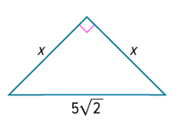

Exit Ticket
