Section 6-3 Medians and Altitudes of Triangles
Content Objective: Students solve problems using medians and altitudes in triangles.
Vocabulary: median, centroid theorem, altitude of a triangle, orthocenter

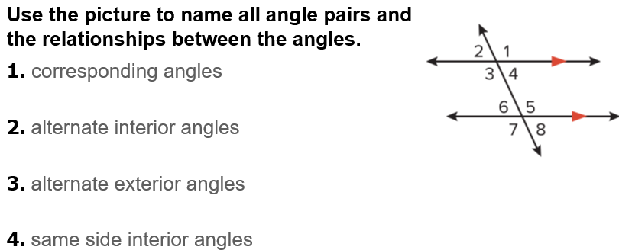
Warm up exercise

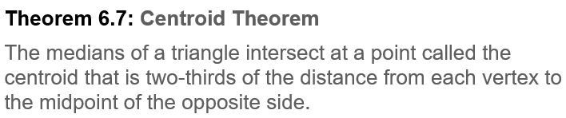
Notes…

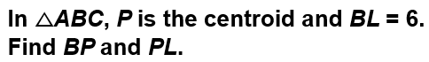  Example #1 | 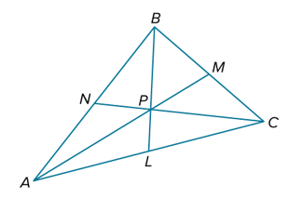

Example #2   | 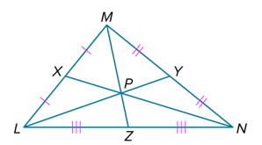

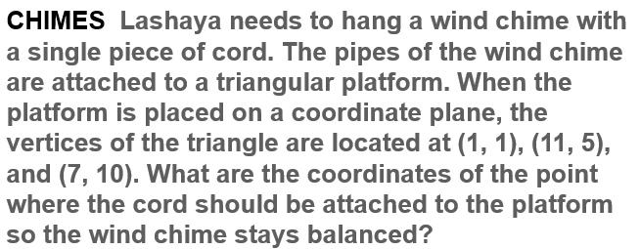  Example #3 | 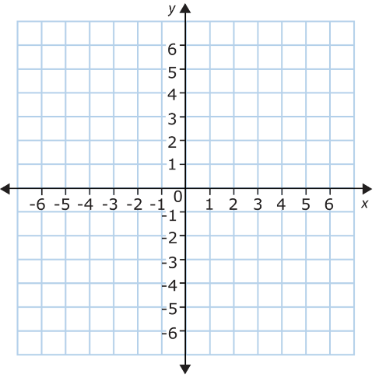

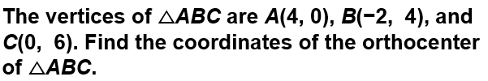
Example #4

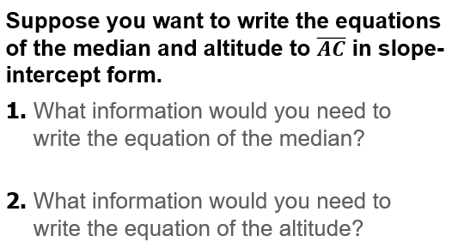  Exit Tickets…  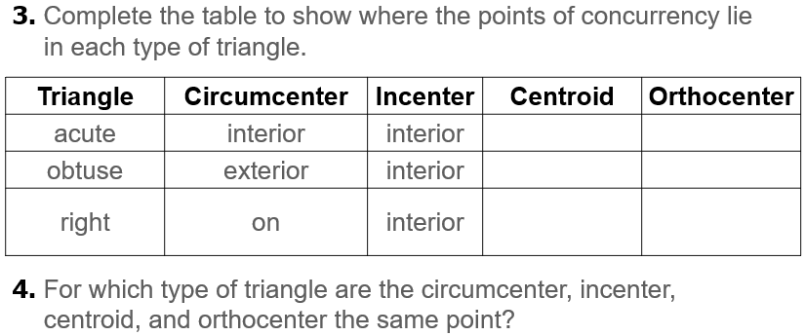 | 