Section 10-1 Circles and Circumference
Content Objective: Students find and apply the definitions of radius and diameter to find circumference and measures in intersecting circles.

Vocabulary: circle, center of a circle, radius, chord, diameter, pi, concentric circles, similar circles, congruent circles
Warm up exercise

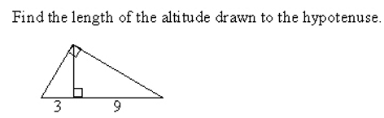

Notes…  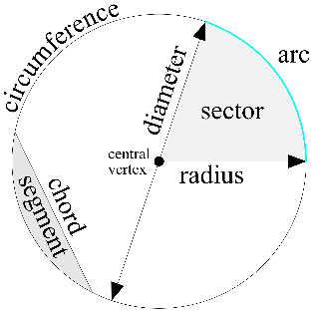  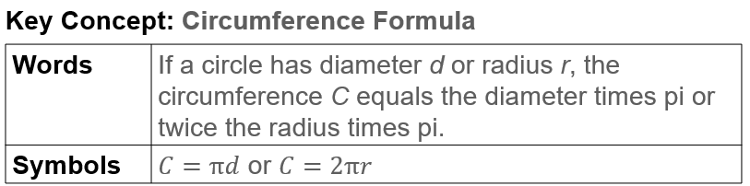 | 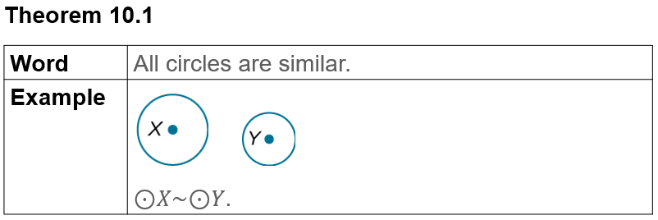  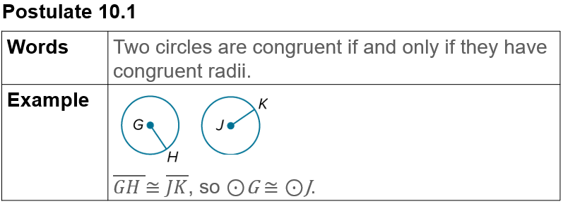
Example #1   | 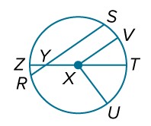

Example #2   | 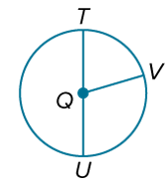

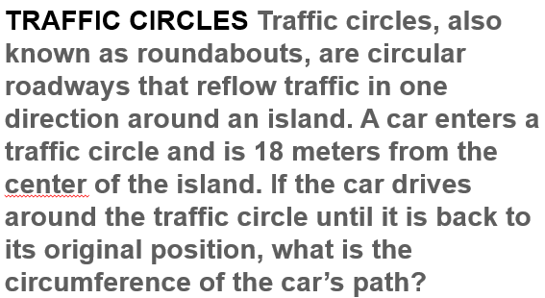  Example #3 | 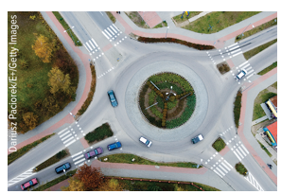


Example #4

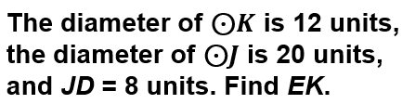  Example #5 | 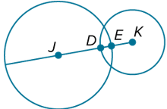

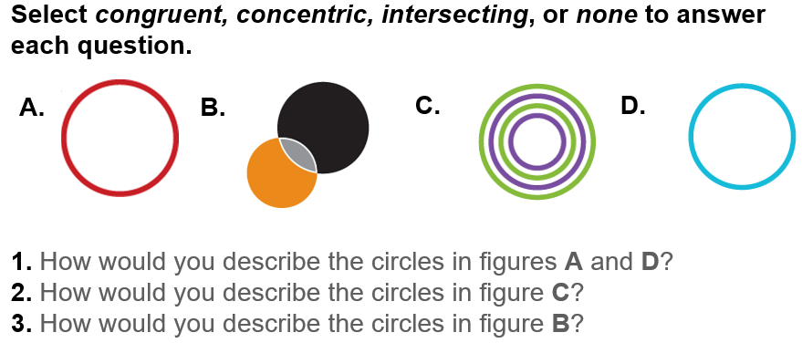
Exit Ticket

