Section 10-7 Equations of Circles
Content Objective: Students write and graph the equations of circles using key features.

Vocabulary: Equation of a circle standard form, completing the square
Warm up exercise
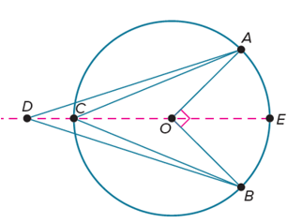
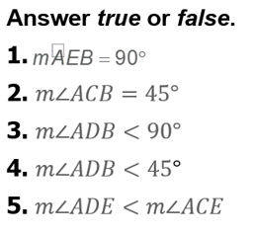

Notes…
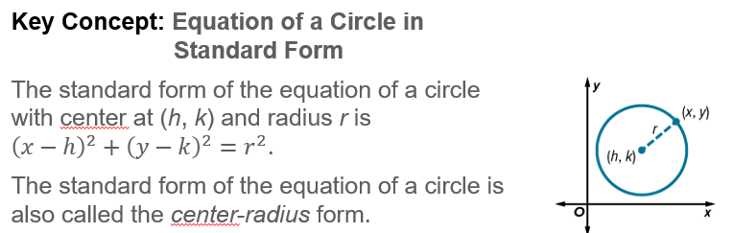

Example #1  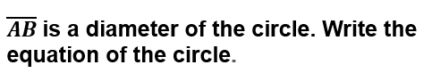 | 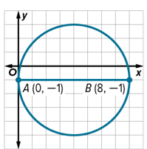
Example #2
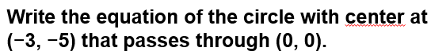

Example #3
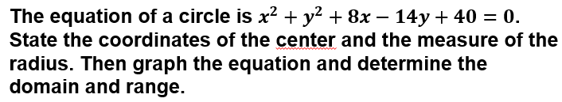

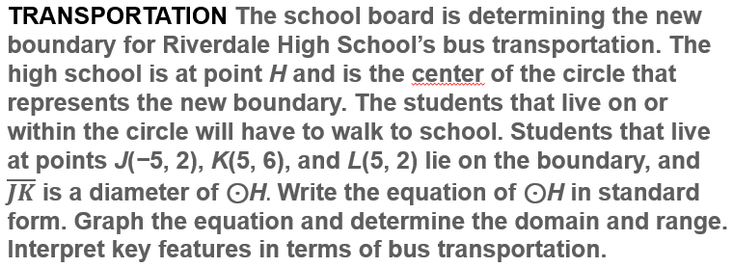
Example #4

Example #5
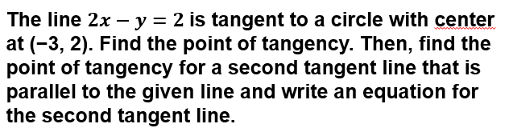

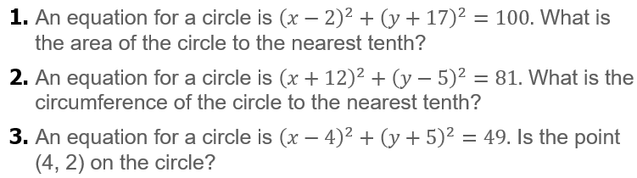
Exit Ticket

