Section 1-3 Locating Points Using Ratios
Content Objective:
Students will find points that partition line segments on number lines and determine the coordinates of a point on a line segment that partitions the segment in a given ratio on the coordinate plane.

Vocabulary: section formula on a number line, section formula on a coordinate plane
Warm up exercise  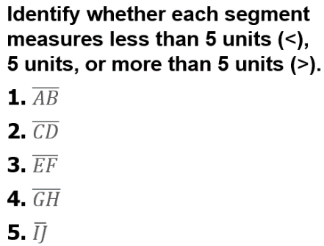 | 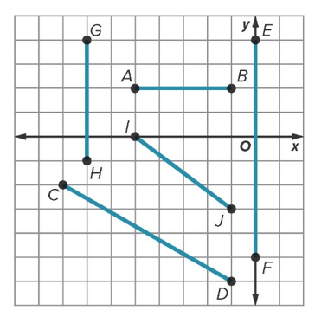

Example #1 | 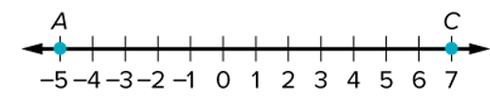

Example #2   | 

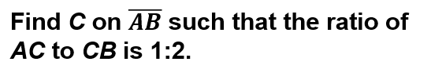  Example #3 | 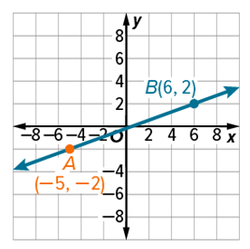

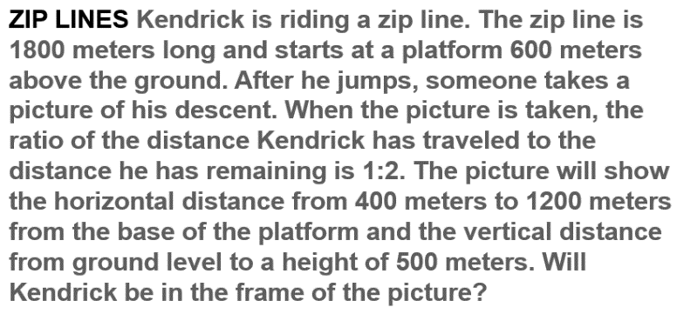
Example #4

Exit Ticket  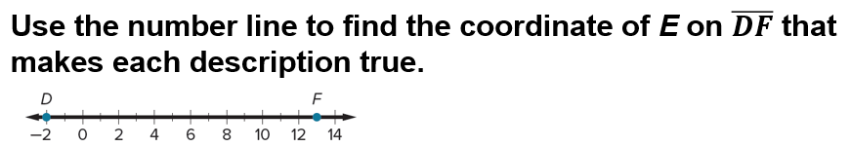 | 