Section 11-8 Applying Similarity to Solid Figures
Content Objective: Students find measures of similar figures and solids
by using scale factors.

Vocabulary: Areas of similar polygons, similar solids
Warm up exercise

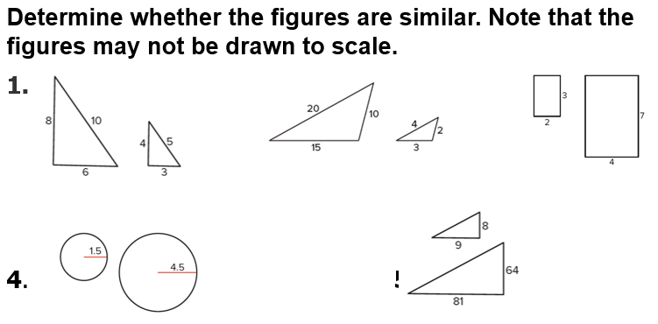

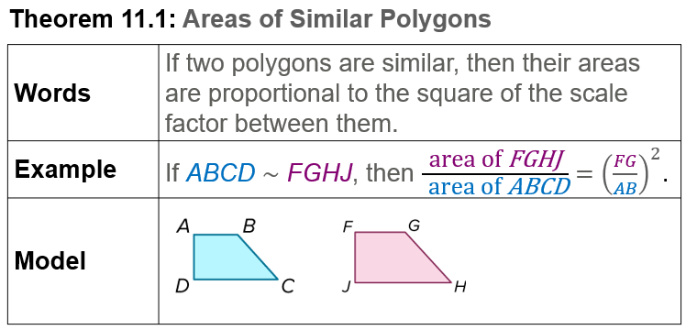  Notes… | 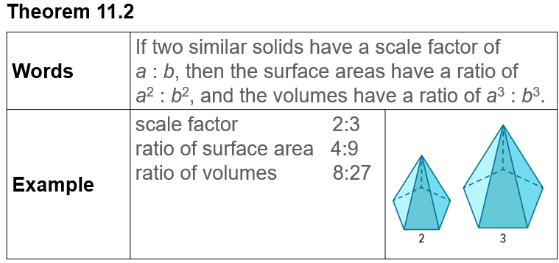  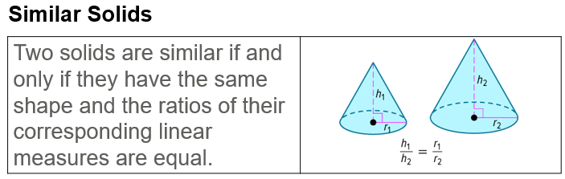
Example #1  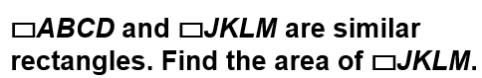 | 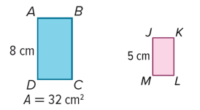
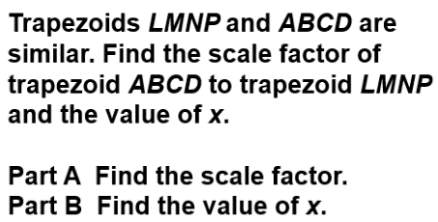  Example #2 | 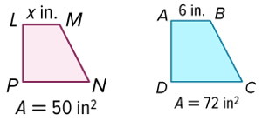

Example #3
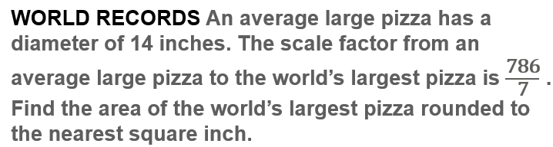

Example #4  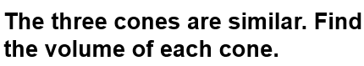 | 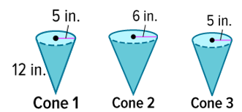

Example #5
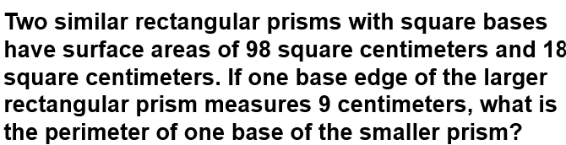

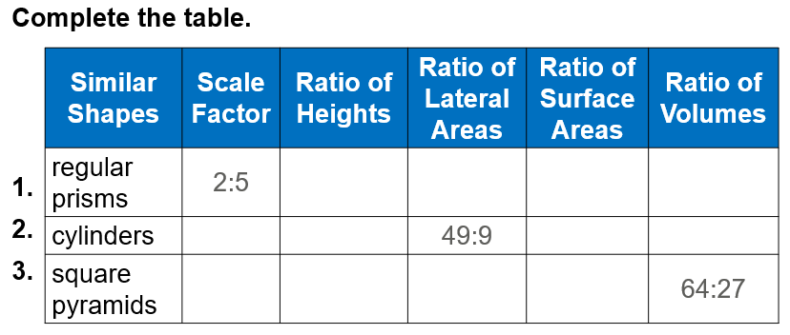
Exit Ticket…

