Section 9-2B Special Right Triangles
Content Objective: Students will solve problems by using the properties of $30°-60°-90°$ triangles.
Vocabulary: 30-60-90 triangle

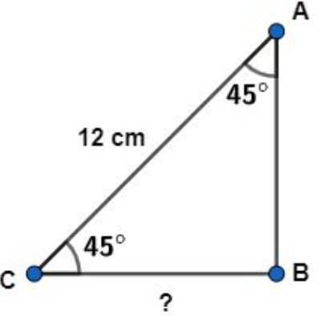
Warm up exercise

Find the missing side.

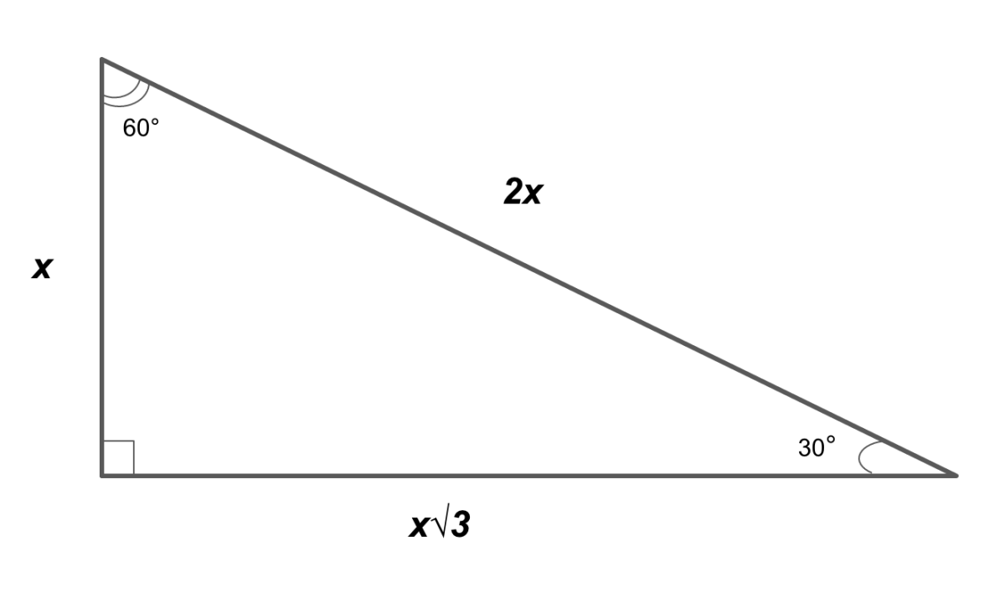
Notes…

30-60-90 triangle

Example #1A  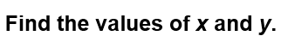 | 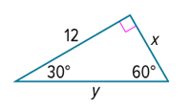

Example #1B  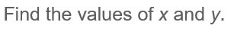 | 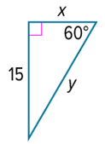

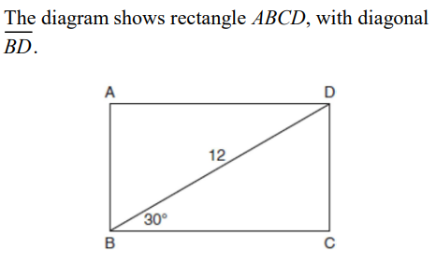  Example #2 | 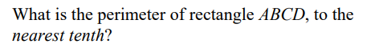

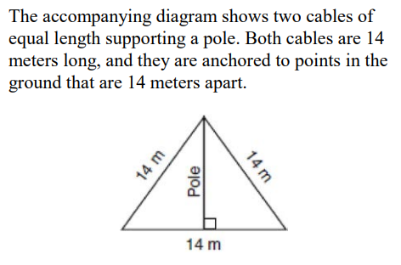
Example #3

Example #4  Find the value of a, b, c, and d. | 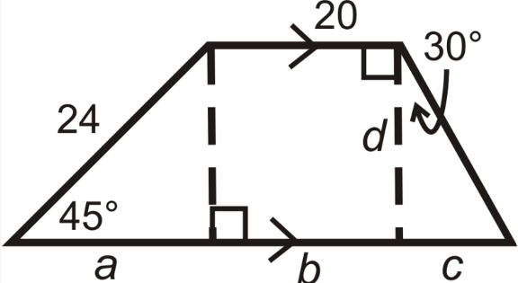

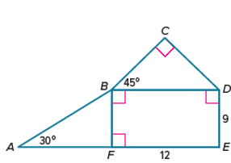
Exit Ticket
Find the measurements of AB, CB, CD, BD, BF.

