Section 10-5 Tangents
Content Objective: Students solve problems using relationships between circles and tangents and investigate constructions with circles.

Vocabulary: tangent of a circle, point of tangency, common tangent, tangent of a circle theorem, circumscribed angle, circumscribed polygon, inscribed circle, inscribed circle of a triangle
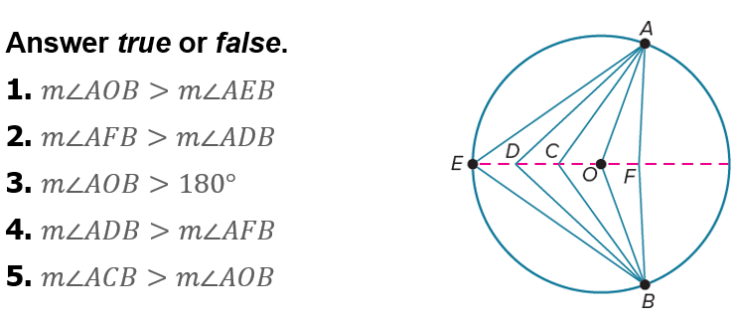
Warm up exercise

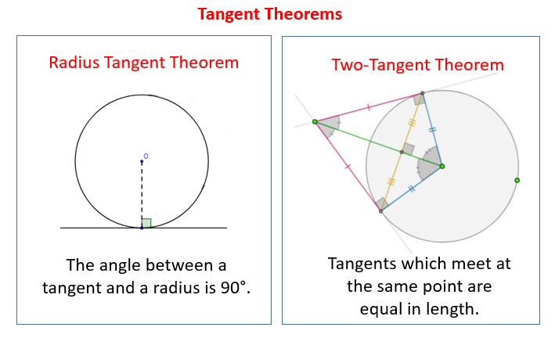  Notes… | 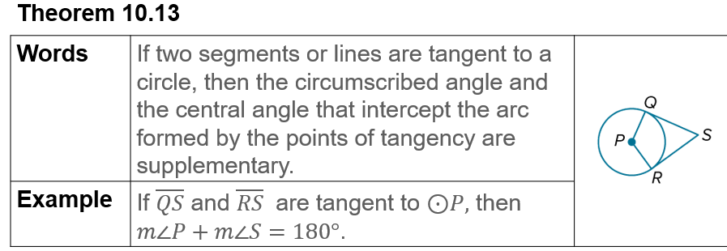

Example #1  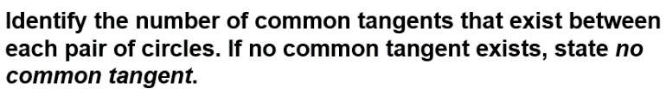 | 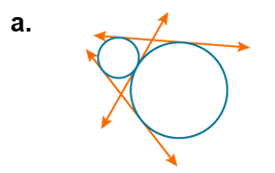
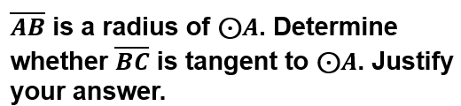  Example #2 | 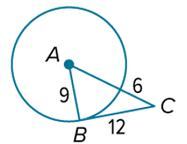

Example #3  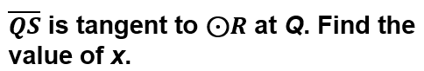 | 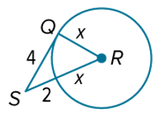

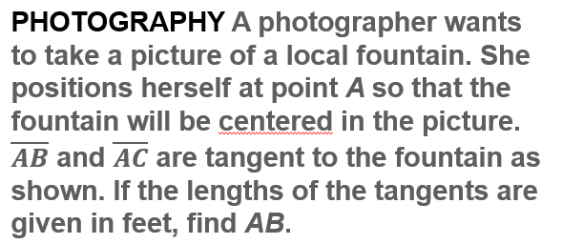  Example #4 | 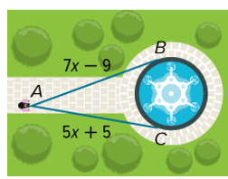

Example #5  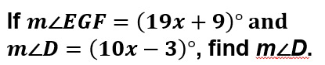 | 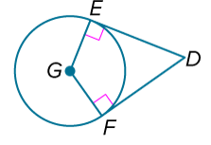

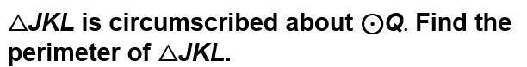  Example #6 | 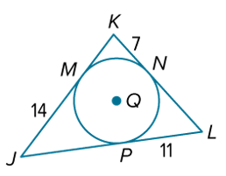

Exit Ticket
