Section 1-5 Locating Points using Weighted Averages
Content Objective:
Students will locate points on a number line and a coordinate plane by using weighted averages.

Vocabulary: weighted average, weighted average on a number line, weighted average on a coordinate plane
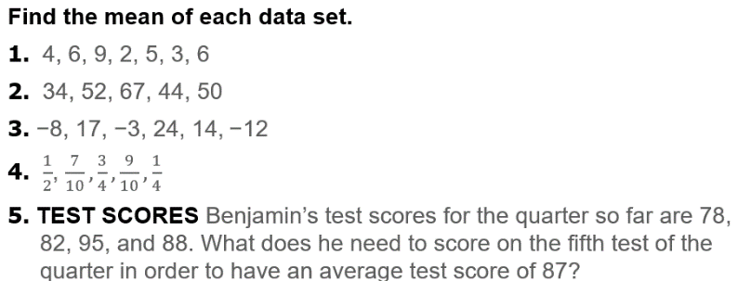  Warm up exercise | 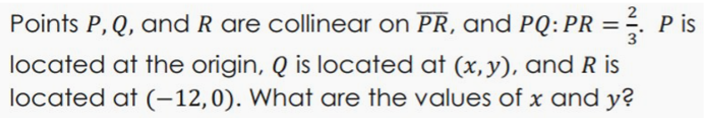  Warm up exercise

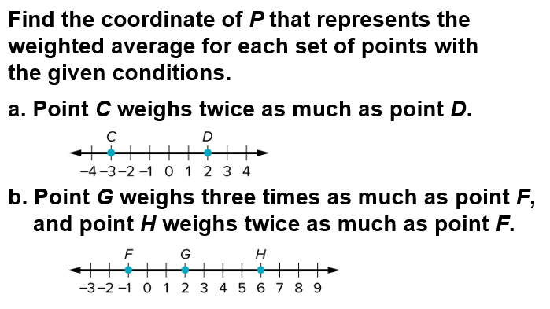
Example #1

Example #2  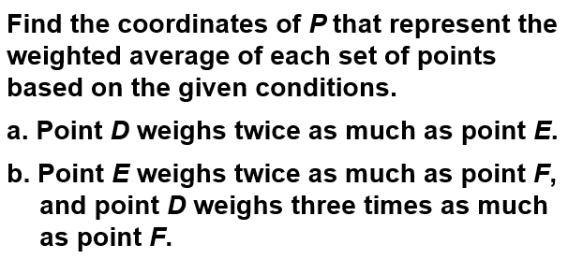 | 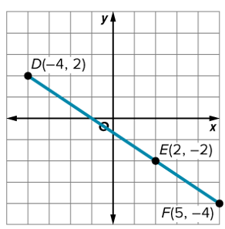

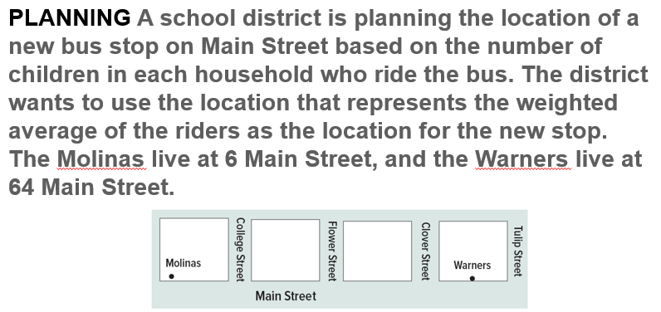
Example #3

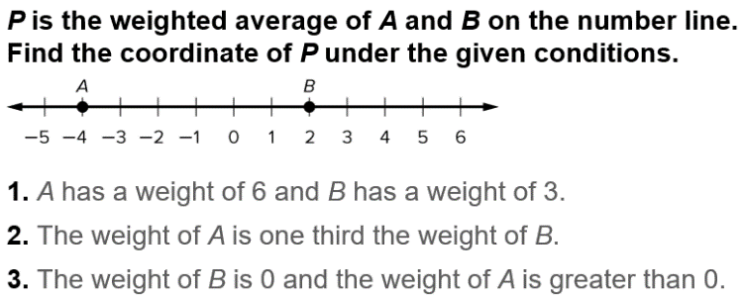
Exit Ticket

