Section 11-5 Cross Sections and Solids Revolution
Content Objective: Students identify the shapes of cross sections formed by cuts to a solid, the three-dimensional objects generated by rotations of two-dimensional objects, and the three-dimensional symmetries of solids.
Vocabulary: cross section, plane symmetry, solid of revolution, axis symmetry,
Warm up exercise
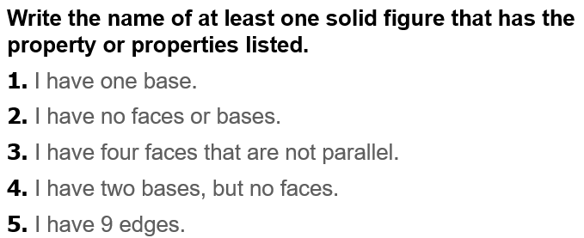

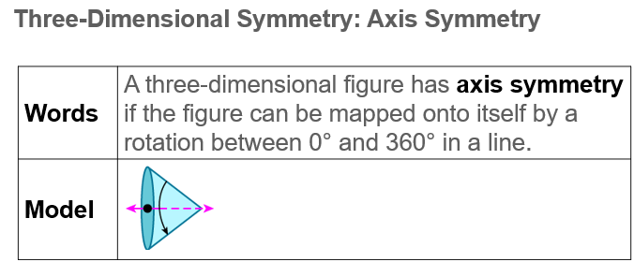  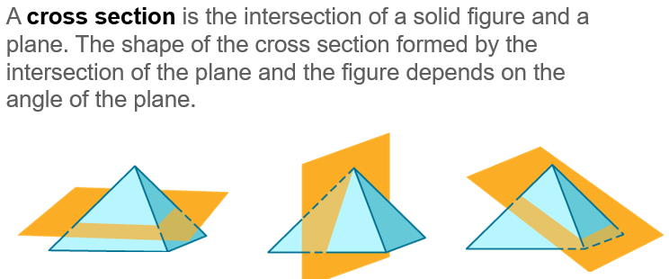  Notes… | 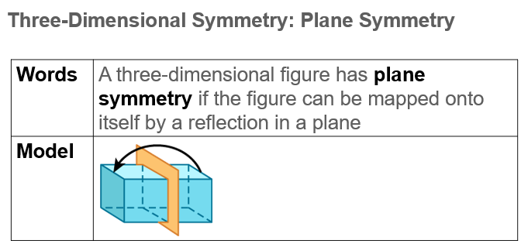
Example #1  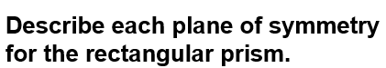 | 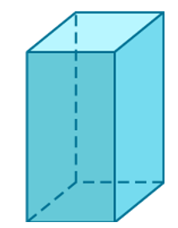
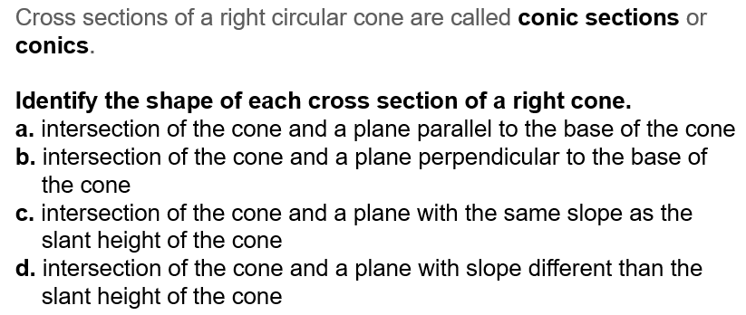
Example #2

Example #3  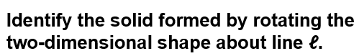 | 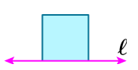

Example #4
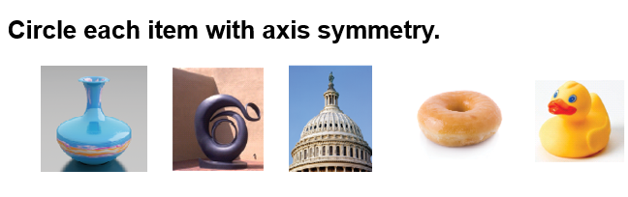

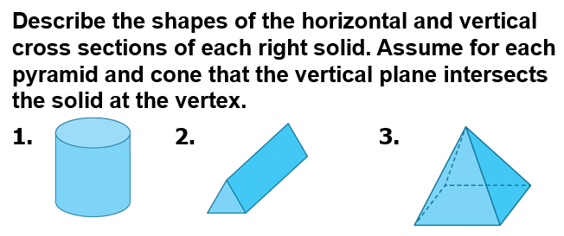
Exit ticket…
