Section 10-4 Inscribed Angles
Content Objective: Students solve problems using inscribed angles.

Vocabulary: inscribed angles, inscribed polygon, circumscribed circle of a polygon, circumscribed circle of a triangle
Warm up exercise
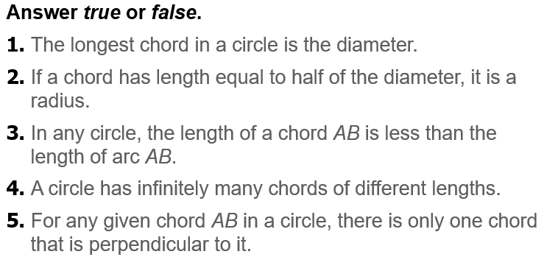

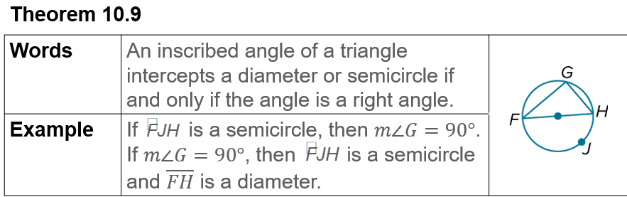  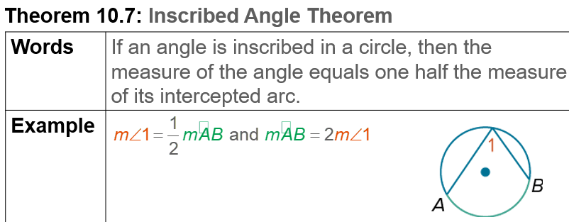  Notes… | 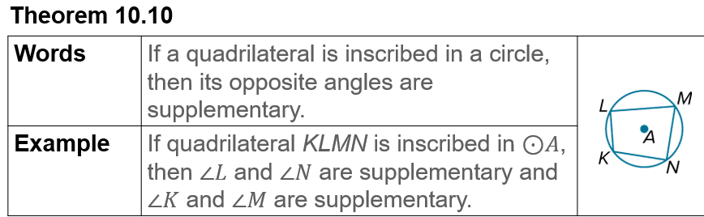  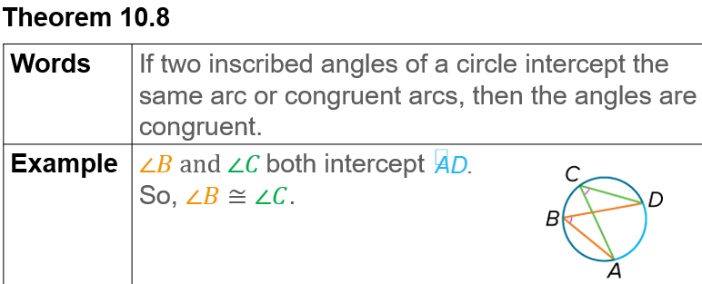

Example #1  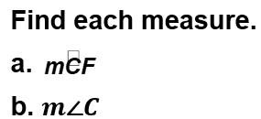 | 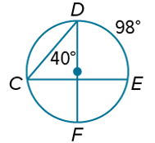
Example #2   | 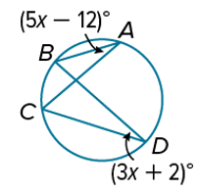

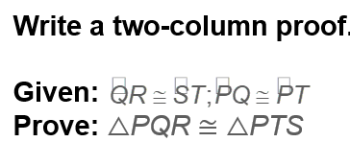  Example #3  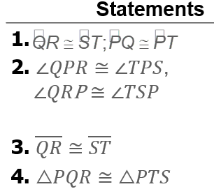 | 

Example #4   | 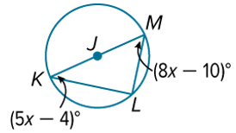

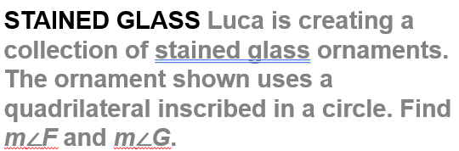  Example #5 | 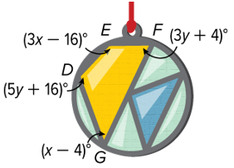

Exit Ticket
